SUPPLEMENTARY MATERIALS
SM1. TCS haplotype network based on the 367 bp cytb fragment, overlapping between sequences used in this study, Panova et al., 2011 and Doellman et al., 2011; 186 sequences of L. arcana, L. compressa and L. saxatilis were included.
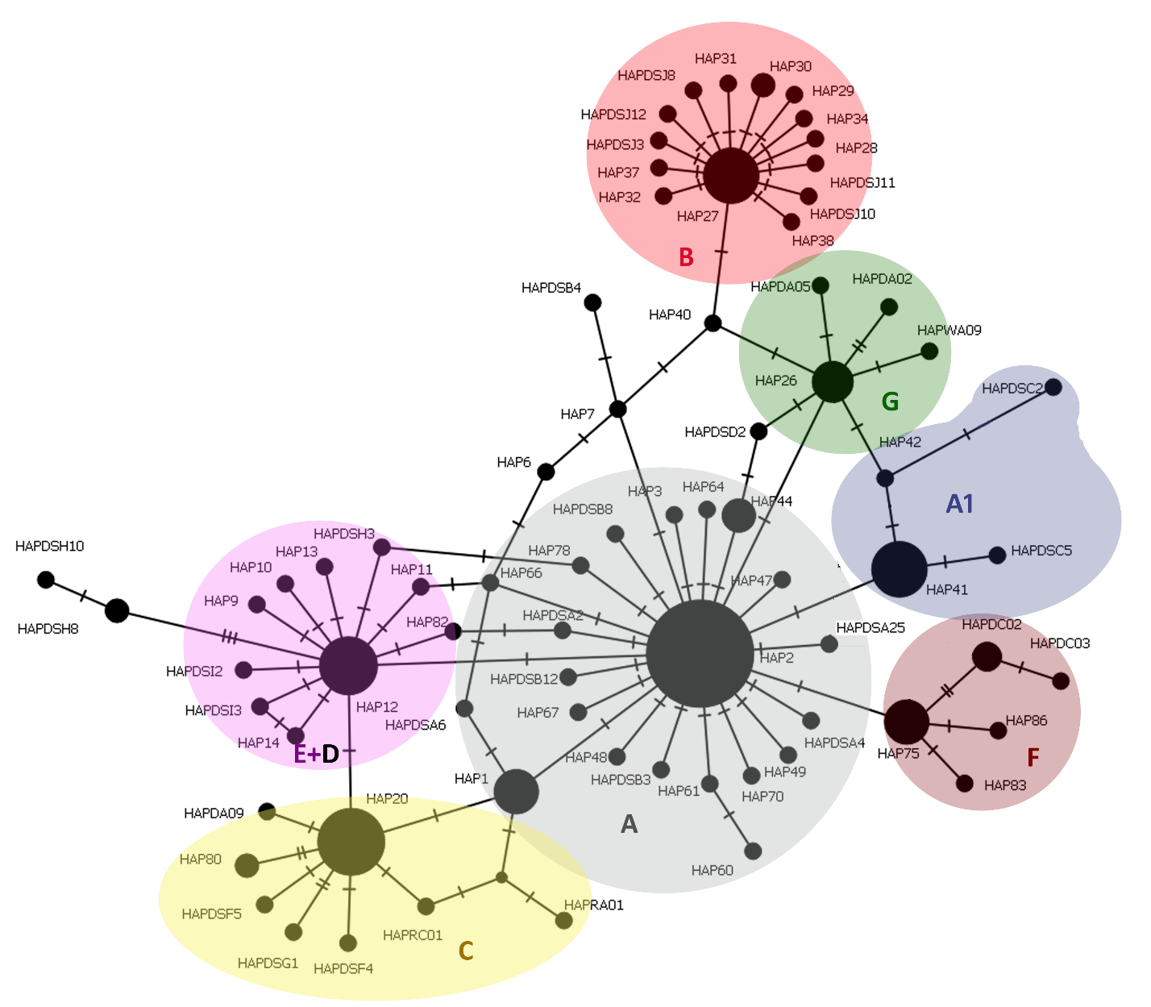

SM2. Bayesian phylogenetic tree of the 625 bp cytb haplotype sequences of Littorina arcana, L. compressa and L. saxatilis from this study and from Panova et al., 2011.
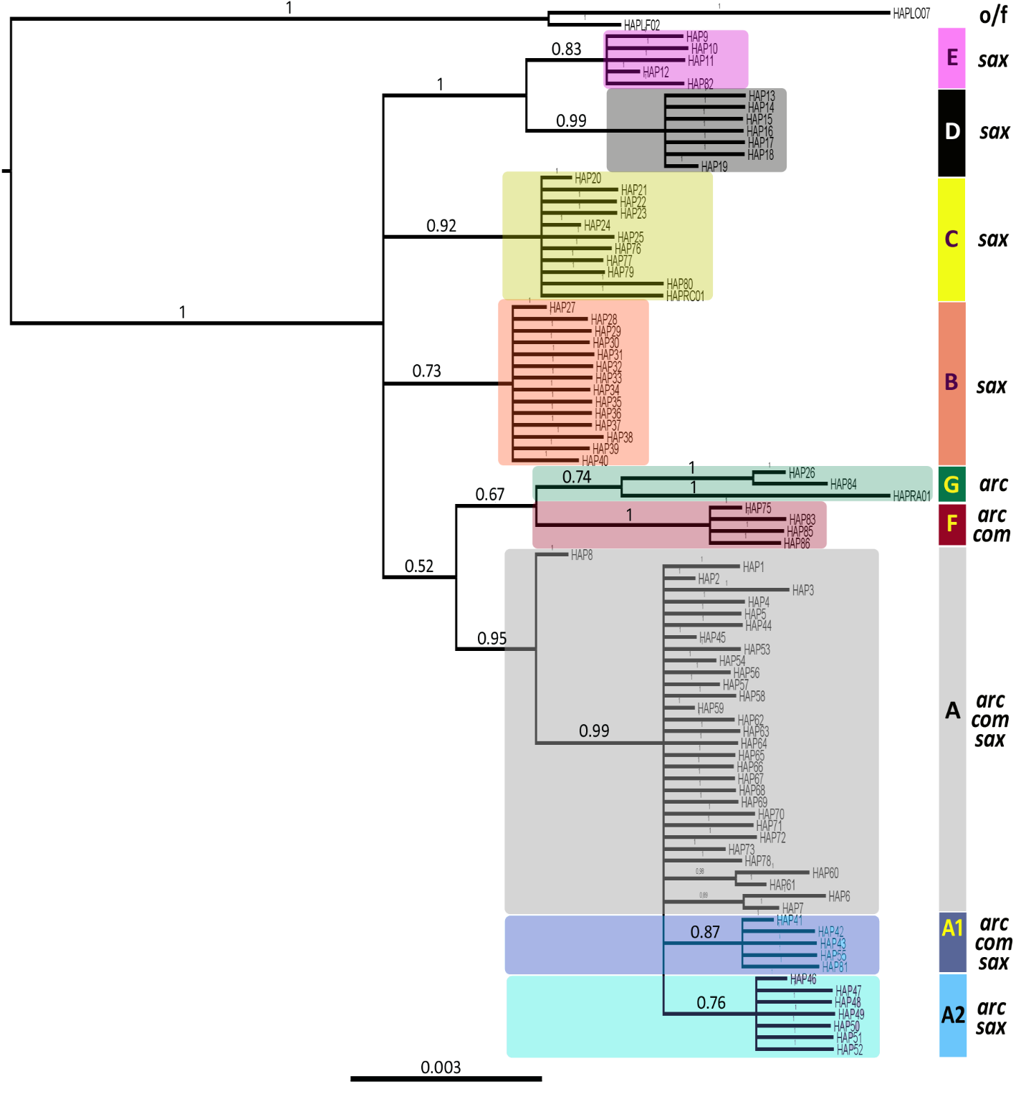

SM3. Bayesian phylogenetic tree based on the 367 bp cytb fragment, overlapping between sequences used in our study, Panova et al., 2011 and Doellman et al., 2011; 186 cytb sequences of Littorina arcana, L. compressa and L. saxatilis are included as well as those of L. obtusata and L. fabalis as the outgroups.
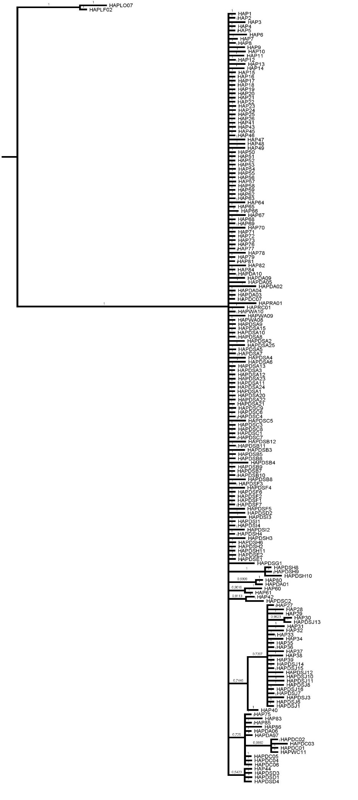
SM4. Fst values and corresponding p-values after pairwise comparison of populations of the three ‘saxatilis’ species from four collection sites based on the cytb data. DZ: Dalnye Zelentsy (Barents Sea); TRO: Tromsø (Norwegian Sea); ARC: L. arcana; COM: L. compressa; SAX: L. saxatilis
BY DISTANCE Fst |  |  |  |  |  | DZ | ARC | COM | SAX
Pairwise FSTs below the diagonal, p-values – above. |  |  |  |  |  | ARC |  | 0.00195+-0.0014 | 0.00098+-0.0010
 |  |  |  |  |  | COM | 0,22348 |  | 0.00000+-0.0000
ARC | DZ | Bodø | Tromsø | Wales |  | SAX | 0,17535 | 0,37384
DZ |  | 0.00000+-0.0000 | 0.00000+-0.0000 | 0.00000+-0.0000
Bodø | 0,29492 |  | 0.00000+-0.0000 | 0.00293+-0.0016 |  | Bodø | ARC | COM | v
Tromsø | 0,63718 | 0,54727 |  | 0.00000+-0.0000 |  | ARC |  | 0.02637+-0.0048 | 0.13184+-0.0109
Wales | 0,49847 | 0,18947 | 0,75937 |  |  | COM | 0,39593 |  | 0.12891+-0.0097
MEAN | 0,48778 |  |  |  |  | SAX | 0,57556 | 0,45486
COM | DZ | Bodø | Tromsø | Wales
DZ |  | 0.08008+-0.0088 | 0.00000+-0.0000 | 0.03125+-0.0053 |  | TRO | ARC | COM | SAX
Bodø | 0,09806 |  | 0.00195+-0.0014 | 0.21875+-0.0121 |  | ARC |  | 0.00000+-0.0000 | 0.00000+-0.0000
Tromsø | 0,37995 | 0,65025 |  | 0.00000+-0.0000 |  | COM | 0,83116 |  | 0.00000+-0.0000
Wales | 0,11889 | 0,06771 | 0,57725 |  |  | SAX | 0,721 | 0,75602
MEAN | 0,3153517
 |  |  |  |  |  | WAL | ARC | COM | SAX
SAX | DZ | Bodø | Tromsø | Wales |  | ARC |  | 0.00000+-0.0000 | 0.00000+-0.0000
DZ |  | 0.00195+-0.0014 | 0.01172+-0.0036 | 0.00000+-0.0000 |  | COM | 0,53358 |  | 0.00098+-0.0010
Bodø | 0,3567 |  | 0.20215+-0.0119 | 0.00000+-0.0000 |  | SAX | 0,22209 | 0,22825
Tromsø | 0,11417 | 0,03937 |  | 0.00000+-0.0000
Wales | 0,41826 | 0,44581 | 0,30331 |  |  | MEAN | SAX/ARC | 0,4235
MEAN | 0,279603 |  |  |  |  |  | SAX/COM | 0,4532425
 |  |  |  |  |  |  | ARC/COM | 0,4960375
HAPLOTYPE frequencies Fst
Pairwise FSTs below the diagonal, p-values – above. |  |  |  |  |  | DZ | ARC | COM | SAX
ARC | DZ | Bodø | Tromsø | Wales |  | ARC |  | 0.00195+-0.0014 | 0.00098+-0.0010
DZ |  | 0.00000+-0.0000 | 0.00000+-0.0000 | 0.00000+-0.0000 |  | COM | 0,1704 |  | 0.00000+-0.0000
Bodø | 0,15254 |  | 0.00000+-0.0000 | 0.00293+-0.0016 |  | SAX | 0,17535 | 0,26617
Tromsø | 0,52326 | 0,34764 |  | 0.00000+-0.0000
Wales | 0,29325 | 0,22325 | 0,53229
MEAN | 0,3453717 |  |  |  |  | Bodø | ARC | COM | SAX
 |  |  |  |  |  | ARC |  | 0.00000+-0.0000
COM | DZ | Bodø | Tromsø | Wales |  | COM | 0,32921
DZ |  | 0.08008+-0.0088 | 0.00000+-0.0000 | 0.03125+-0.0053 |  | SAX | 0,24689 | 0,46469
Bodø | 0,39245 |  | 0.00195+-0.0014 | 0.21875+-0.0121
Tromsø | 0,34348 | 0,6192 |  | 0.00000+-0.0000 |  | TRO | ARC | COM | SAX
Wales | 0,28996 | 0,332 | 0,45366 |  |  | ARC |  | 0.00000+-0.0000 | 0.00000+-0.0000
MEAN | 0,405125 |  |  |  |  | COM | 0,79249 |  | 0.00000+-0.0000
 |  |  |  |  |  | SAX | 0,48656 | 0,52136
SAX | DZ | Bodø | Tromsø | Wales
DZ |  | 0.00195+-0.0014 | 0.01172+-0.0036 | 0.00000+-0.0000 |  | WAL | ARC | COM | SAX
Bodø | 0,20001 |  | 0.20215+-0.0119 | 0.00000+-0.0000 |  | ARC |  | 0.00000+-0.0000 | 0.00000+-0.0000
Tromsø | 0,09625 | 0,01202 |  | 0.00000+-0.0000 |  | COM | 0,24319 |  | 0.00098+-0.0010
Wales | 0,21292 | 0,20413 | 0,08883 |  |  | SAX | 0,196 | 0,21223
MEAN | 0,160428
 |  |  |  |  |  | MEAN | SAX/ARC | 0,2762
 |  |  |  |  |  |  | SAX/COM | 0,3661125
 |  |  |  |  |  |  | ARC/COM | 0,3838225

SM5.1. Discriminant analysis of principal components (DAPC) results. Scatter plot (upper) based on the DAPC output. Populations are indicated by different colours. Dots represent different individuals. Scatter plots results from DAPC for all nine local populations of L. saxatilis (LS), L. arcana (LA), and L. compressa (LC) based on five SSR loci. Insets represent the eigenvalues of retained principal components (top left), and the eigenvalues of discriminant functions (top right). Density plot (lower) showing an overlap of Littorina populations along the first discriminant axis.

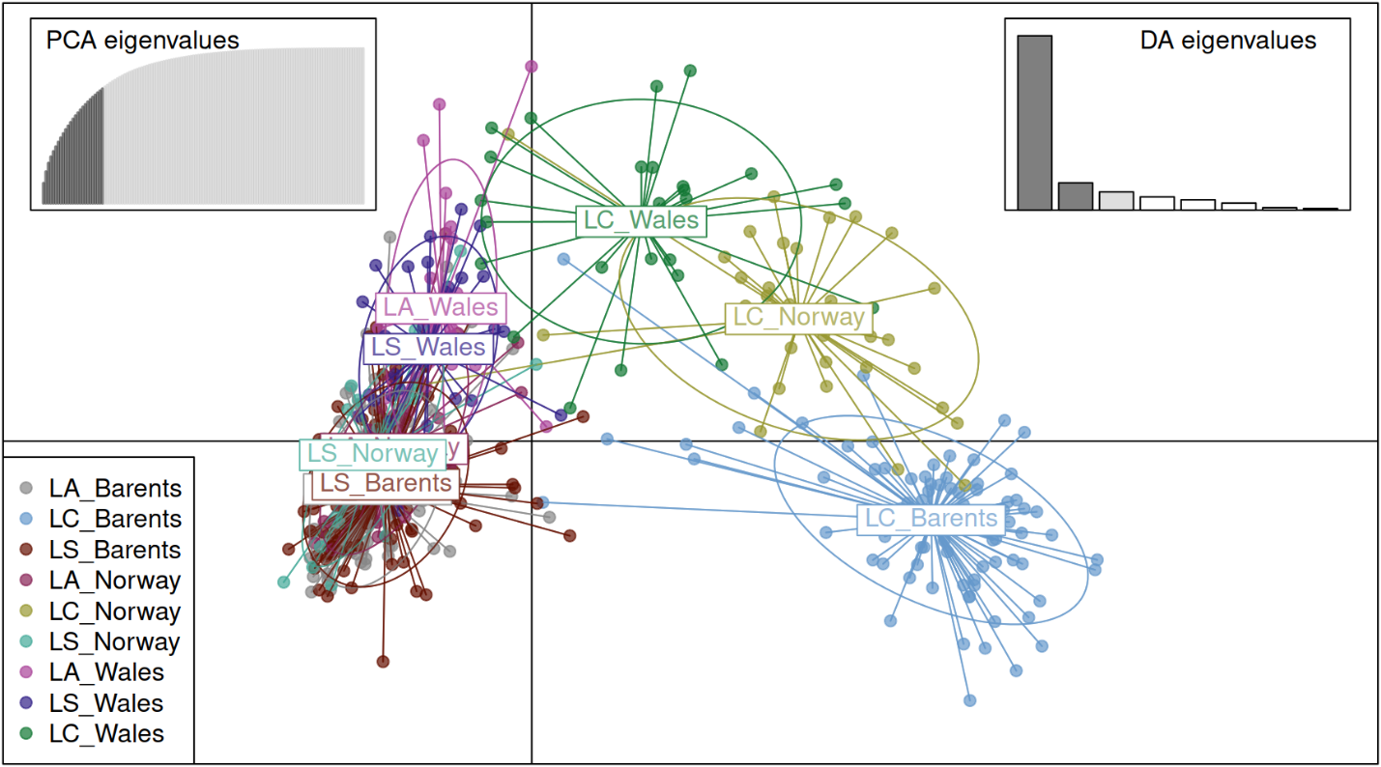
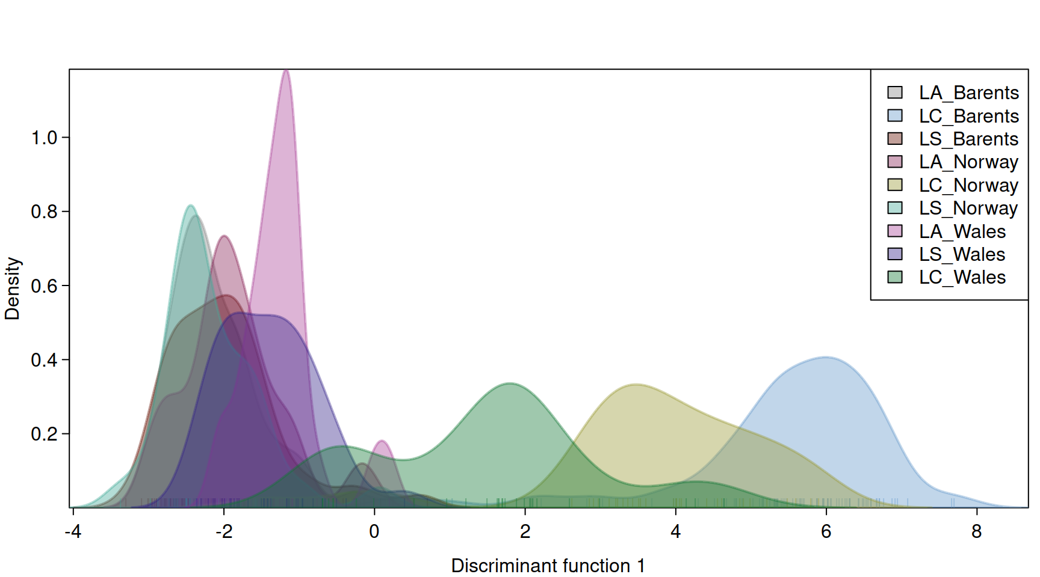

SM5.2. Discriminant analysis of principal components (DAPC) results. Scatter plot (upper) based on the DAPC output. Populations are indicated by different colours. Dots represent different individuals. Scatter plots results from DAPC for all twelve local populations (Chevry and Oscar site near Dalnye Zelentsy analysed separately) of L. saxatilis (LS), L. arcana (LA), and L. compressa (LC) based on five SSR loci. Insets represent the eigenvalues of retained principal components (top left), and the eigenvalues of discriminant functions (top right). Density plot (lower) showing an overlap of Littorina populations along the first discriminant axis.

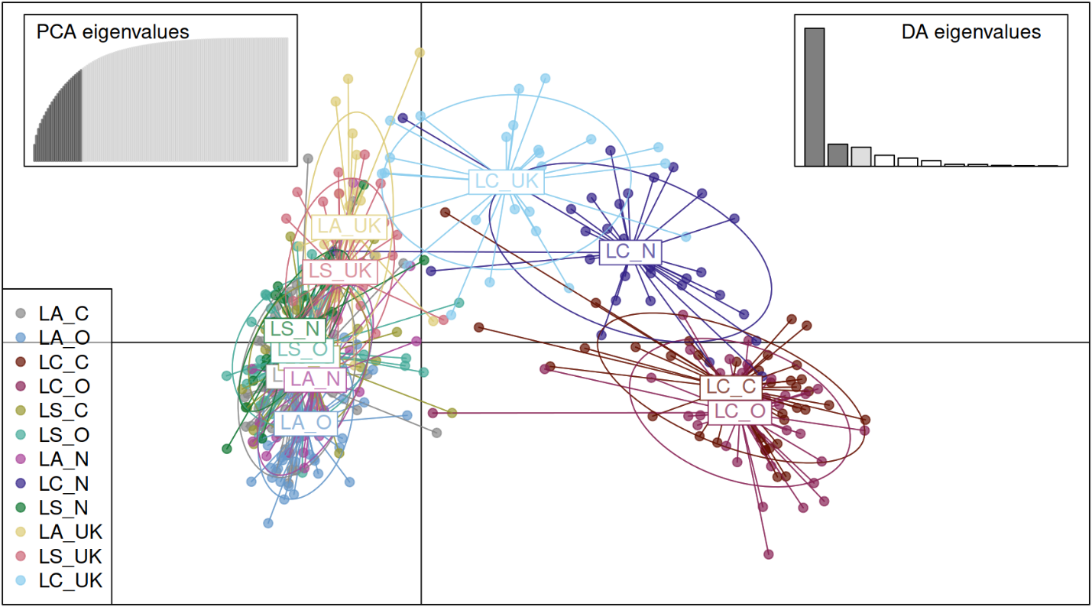
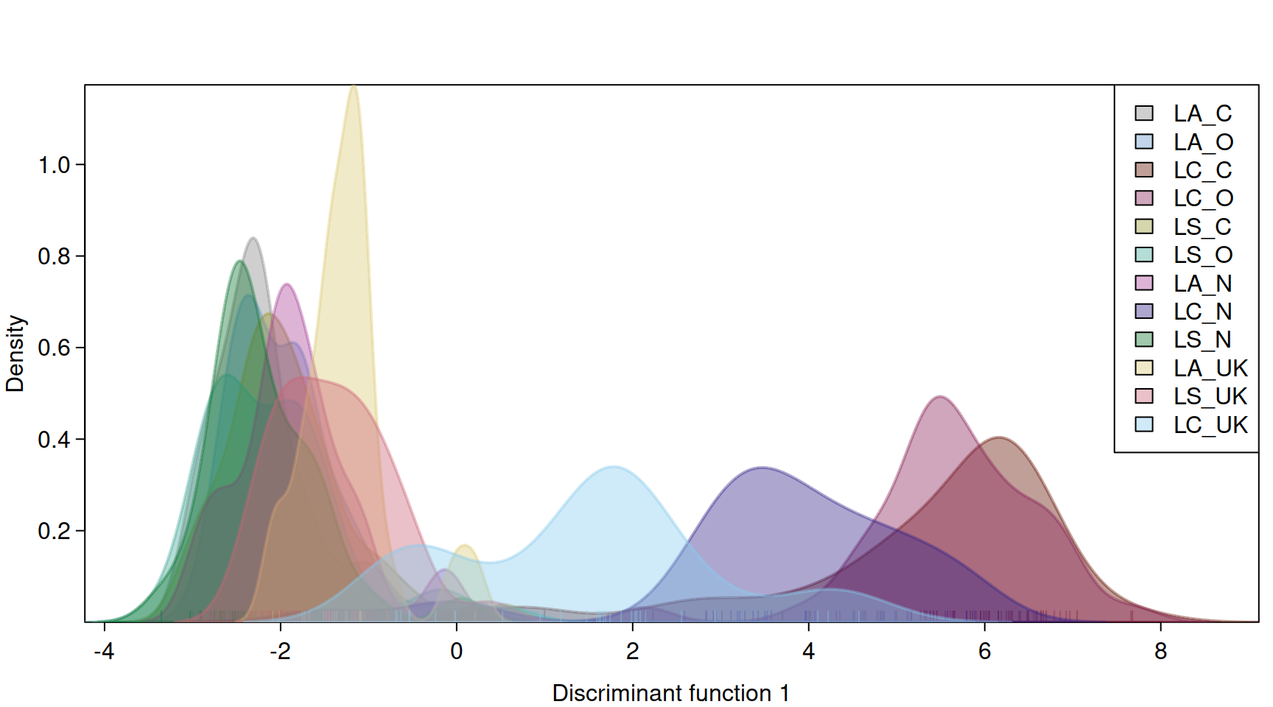

SM6. Heatmap of pairwise Fst values among nine local populations of L. saxatilis (LS), L. arcana (LA), and L. compressa (LC). The analysis was based on five SSR loci; Norway: site of Tromsø, Norwegian Sea; Barents: Dalnye Zelentsy, Barents Sea.
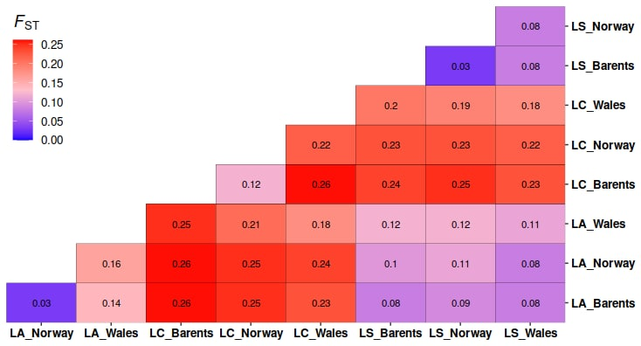

SM7. SAMOVA results of population of the three ‘saxatilis’ species from four collection sites based on microsatellite data.
GROUPS | Fixation Indices | Source of variation | Df | Sum of squares | Variance components | Percentage of variation
#Group1  "LA_CBarents"  "LA_OBarents"  "LS_CBarents"  "LS_OBarents"  "LA_Norway"  "LS_Norway"  "LA_Wales"  "LS_Wales"  "LC_Wales"  #Group2  "LC_CBarents"  "LC_OBarents"  "LC_Norway" | FIS=0.33322  FSC=0.07691  FCT=0.16527  FIT=0.48622 | Among groups  Among populations within groups  Among individuals within populations  Within individuals | 1  10  323  335 | 110.607  110.883  809.696  420.000 | 0.40331  0.15665  0.62653  1.25373 | 16.53  6.42  25.68  51.38
#Group1  "LC_Wales"  #Group2  "LC_CBarents"  "LC_OBarents"  #Group3  "LA_CBarents"  "LA_OBarents"  "LS_CBarents"  "LS_OBarents"  "LA_Norway"  "LS_Norway"  "LA_Wales"  "LS_Wales"  #Group4  "LC_Norway" | FIS=0.33322  FSC=0.06930  FCT=0.16587  FIT=0.48235 | Among groups  Among populations within groups  Among individuals within populations  Within individuals | 3  8  323  335 | 133.123  88.367  809.696  420.000 | 0.40173  0.14000  0.62653  1.25373 | 16.59  5.78  25.87  51.76
#Group1  "LS_Wales"  #Group2  "LA_CBarents"  "LS_CBarents"  "LS_OBarents"  "LS_Norway"  #Group3  "LC_Norway"  "LC_Wales"  #Group4  "LA_OBarents"  "LA_Norway"  #Group5  "LA_Wales"  #Group6  "LC_CBarents"  "LC_OBarents" | FIS=0.33322  FSC=0.02720  FCT=0.14735  FIT=0.44693 | Among groups  Among populations within groups  Among individuals within populations  Within individuals | 5  6  323  335 | 188.007  33.483  809.696  420.000 | 0.33401  0.05257  0.62653  1.25373 | 14.73  2.32  27.64  55.31

