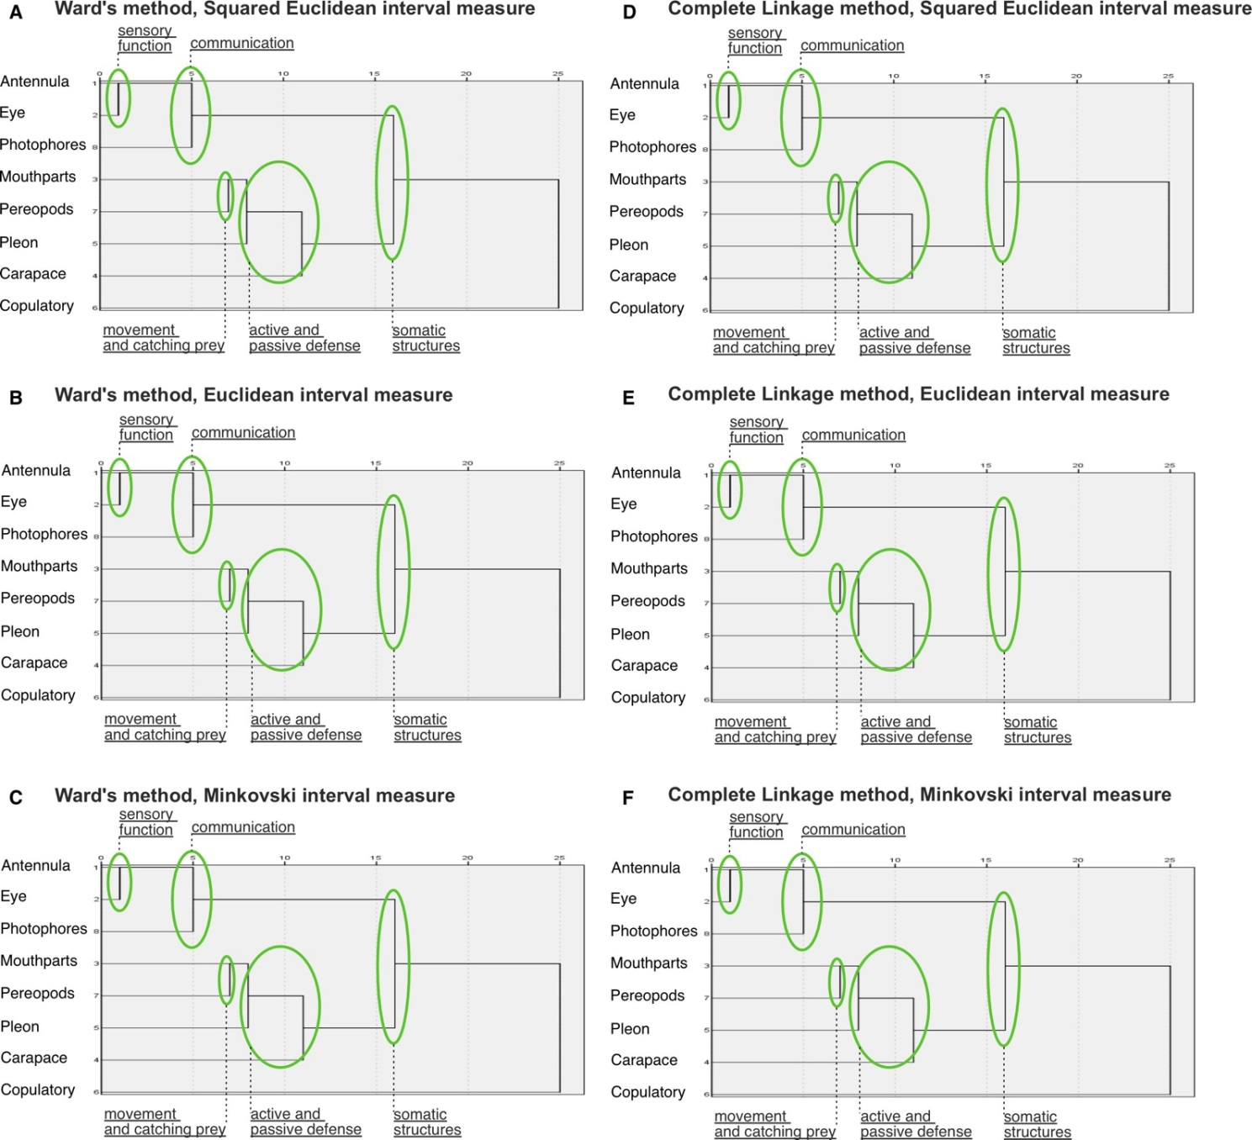**Fig. S1.** Hierarchical dendrograms retrieved using Ward’s (A-C) and Complete Linkage (D-F) Methods. Interval measure: Squared Euclidean (A, D), and Euclidean (B, E), and Minkovski (C, F). Permanent parts of dendrograms are marked by ovals.

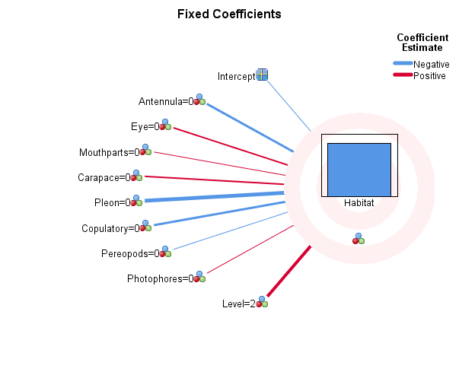**Analysis 1**

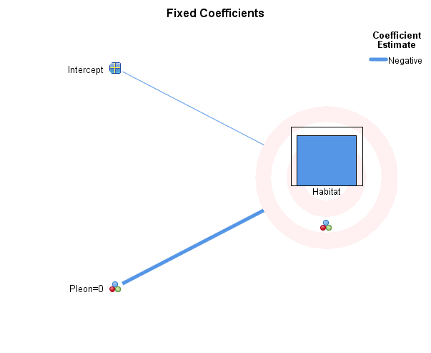**Analysis 2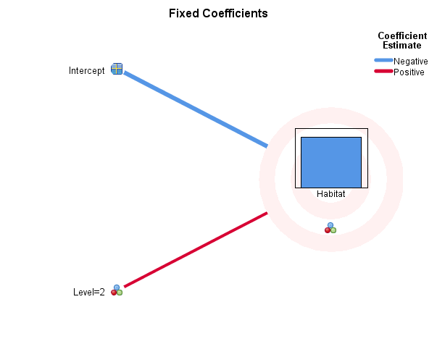Analysis 3**

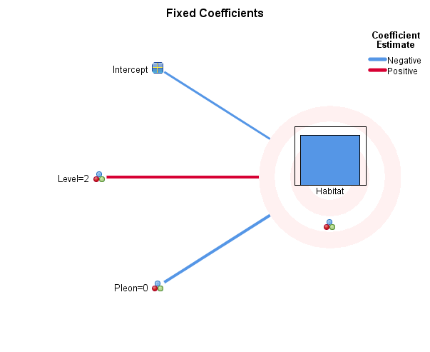**Analysis 4**

**Fig. S2.** Visualized GLMMs with Habitat (pelagic or benthopelagic) as a target. **Analysis 1**: all nine fixed factors included: (1) Carapace, (2) Pleon, (3) Antennula, (4) Eye, (5) Mouthparts, (6) Pereopods, (7) Photophores, (8) Copulatory structures, and (9) Clade Level. **Analysis 2**: only Pleon included as a fixed factor. **Analysis 3**: only Clade Level included as a fixed factor. **Analysis 4**: both Pleon and Clade Level included as a fixed factors.**Table S1.** Specimens of Pasiphaeoidea morphologically examined for current analyses.

NMHN – National Museum of Natural History, France; ZMMU – Zoological Museum Moscow State University; LACM – Natural History Museum of Los Angeles County, USNM – Smithsonian National Museum of Natural History.

|  |  |  |  |
| --- | --- | --- | --- |
| **Species** | **Locality** | **Museum** | **Collection number** |
| *Alainopasiphaea nudipeda* | 05° 02´S - 11° 17´E | NMHN | NMHN-IU-2014-12074 |
| *Eupasiphae gilesii* | 29° 48´S - 87° 16´E | NMHN | NMHN-IU-2018-1584 |
|  | “P.Lebedev”, cruise V, 1967 | ZMMU |  |
|  | “Prof. Sedletskii” cruise, 1984 г. | ZMMU |  |
| *Eupasiphae latirostris* | 02° 50´S - 55° 36´E | NMHN | NMHN-IU-2018-1585 |
| *Eupasiphae paucidentata* | 21° 05´S - 165°50,05´E | NMHN | NMHN-IU-2018-1586 |
| *Eupasiphae serrata* | 24° 00´S - 162° 08´E | NMHN | NMHN-IU-2018-1587 |
| *Glyphus marsupialis* | 08° 36´S - 131° 33´E | NMHN | MNHN-IU-2018-1583 |
| *Leptochela aculeocaudata* | Red Sea, DJIBOUTI, Hors campagne INVMAR | NMHN | MNHN-IU-2014-11187 |
|  | Bustard Bay, Quinsland, Haul 46/38 (old no.) | Australian museum | P20124 |
| *Leptochela bermudensis* | North Atlantic Ocean, Gulf of Mexico; Unated States; Off Florida. 26° 15 52N; 082° 12 37W. | USNM | USNM 271066 |
|  | North Atlantic Ocean, Unated states,Off South Carolina,31.5317 N, -79.7417 W, Depth (m): 57, Oregon R/V | USNM | USNM 214978 |
| *Leptochela carinata* | North Atlantic Ocean, Gulf of Mexico; Unated States; Off Florida, 26° 46 01N; 082° 06 04W | USNM | USNM 271068 |
|  | Indian ocean, Western Australia; N of Shellbborough 19° 03 30N 119° 03 36E, depth 80 m, CSIRO 0283-121 | USNM | USNM 274684 |
|  | - | LACM | LACM 206368 |
|  | North Atlantic Ocean, Gulf of Mexico; Unated States; Off Florida. 25° 45 53 N; 082° 31 37 W. Depth 31.5 m. | USNM | USNM 233802 |
| *Leptochela chacei* | Vietnam. Cai Dua, collected with light | NMHN | MNHN-IU-2014-11190 |
| *Leptochela crosnieri* | New Caledonia, 22° 28’ 36.0012’’ S; 166° 32’ 23.9748’’ E, VAUBAN, ORSOM | NMHN | MNHN-IU-2014-7581 |
| *Leptochela japonica* | New Caledonia, Lagon Nord, St.500, 225 m, 19° 4’ 18.0012’’ S; 163° 30’ 29.9916’’ E, VAUBAN, ORSTOM | NMHN | MNHN-IU-2012-1077 |
|  | New Caledonia, Grand Passage, St.162, 535 m, 18° 35’ 0.0024’’ S; 163° 10’ 17.9796’’ E, VAUBAN, MUSORSTOM 4 | NMHN | MNHN-IU-2012-1076 |
|  | Bustard Bay, Quinsland, Haul 46/38 (old no.) Net 200. Det. By F.A.Chace. | Australian museum | P11533 |
|  | - | Australian museum | P28770 |
|  | - | Australian museum | P28771 |
| *Leptochela papulata* | North Atlantic Ocean, Unated states,Off South Carolina, 32° 30’ 12’’N, 079° 42’ 12’’W, depth 17 m, Fish sled | USNM | USNM 225164 |
| *Leptochela pugnax* | Philippines, Mansalay, Mindora, Albatross Philippine Exp., ship’s side. | USNM | USNM 154530 |
| *Leptochela robusta* | Philippines, Cebu Island, from stomach of *Archamia lineolata* | USNM | USNM 134773 |
|  | St. Albatross. South coast of Oahu island, T.H. | Australian museum | P9816 |
| *Leptochela serratorbita* | North Atlantic Ocean, Off North Carolina, 34.4033; -76.5967, Dan Moore R/V | USNM | USNM 202848 |
|  | Key West, Florida 1884. | Australian museum | P9882 |
|  | - | LACM | LACM 141707, LACM 141742, LACM 189046, LACM 200050, LACM 206728 |
| *Leptochela sydniensis* | PHILIPPINES N Lubang, MUSORSTOM 1, Vauban, St.63, 191 -195 m, 14° 0’ 29.9988’’ N; 120° 16’ 18.0012’’ E | NMHN | MNHN-IU-2011-5665 |
|  | VIETNAM, Mouillage de Cai Dua, Hors campagne INVMAR | NMHN | MNHN-IU-2011-5662 |
|  | In Port Arthur, Tasmania | Australian museum | P3872 |
|  | Australia, Wattamolla-Bass point 52R2 | Australian museum | P46324 (P.106942) |
|  | Australia, off Sydney, New South Wales, 33° 50’ S 151° 20’ E, Australian Myseum Shelf Bentic Survey | Australian museum | P58020 |
| *Parapasiphae sulcatifrons* | «P. Lebedev» IV cruise, 07.04.1964 | ZMMU | - |
| *Parapasiphae compta* | 48° 20,4’N - 15° 23,3’W | NMHN | Na.4144 |
|  | Off Nantucket Shoals, Sta. 2039. 2369 fms. Steamer Albatross | USNM | USNM 7050 |
| *Parapasiphae cristata* | 42° 59,7’N - 14° 07,2’W | NMHN | NMHN-IU-2018-1590 |
|  | 56° 38’N - 11° 06,4’W | NMHN | NMHN-IU-2018-1589 |
|  | «P. Lebedev» V cruise 1967 | ZMMU | - |
|  | «Ak. Kurchatov» XI cruise 1971 г. | ZMMU | - |
|  | 37° 56´N; 072° 25´ W | USNM | USNM 161430 |
|  | St. 12337 | LACM | LACM 136676 |
|  | St. 10998 | LACM | LACM 161244 |
|  | 8880-63 | LACM | LACM 187894 |
|  | St. 12122, Velero Basin, | LACM | LACM 201664 |
|  | St. 12541 | LACM | LACM 210571 |
|  |  | LACM | LACM 133798 |
|  | Midwater; 1820 fms, Guadelupe Basin Mexico, 29° 34’ 20’’ N, 11° 30’ 00’’ W. R/V Velero IV. | LACM | LACM 190642 |
|  |  | LACM | LACM 225689 |
| *Parapasiphae kensleyi* | North Pacific Ocean, EVE station 198, 31° N, 159° W, MOCNESS Trawl, 4200 m | USNM | USNM 1071776 |
| *Parapasiphae sulcatifrons* | 48° 45’N - 11° 19,8’W      48° 46,6’N - 11° 21,8’W | NMHN | MNHN-IU-2018-1624 |
|  | Sta. 10475, St. Catarina Bas. | LACM | LACM 193199 |
|  | Sta. 8791-63 | LACM | LACM 213504 |
|  | Sta. 11249-66 | LACM | LACM 213585 |
|  | St. 9661 | LACM | LACM 214300 |
|  | St.12000, SAN NIKOLAS | LACM | LACM 195303 |
|  | N.Pt.Guadalupe Is, Mexico, RV Velero IV, sta. 11254 | LACM | LACM 135709 |
| *Pasiphaea barnardi* | XI cruise «Ak. Kurchatov» St. 922 16.12.1971 | ZMMU |  |
| *Pasiphaea multidentata* | II cruise «P. Lebedev» 84. 550-525 (1200) m  26.05.1962 | ZMMU | - |
| *Pasiphaea scotiae* | XI cruise «Ak. Kurchatov» St. 923 16.12.1971 | ZMMU | - |
| *Pasiphaea sivado* | 65 cruise «Vityaz», St. 7934, 13-14.03.1979.  RTAK №11 | ZMMU | - |
|  | Nice Leukart; Ma 185 | ZMMU | - |
|  | Nice, Ma 185 | ZMMU | - |
| *Psathyrocaris hawaiiensis* | North Pacific Ocean, Vic of Mocu Manu, Albatross, Sta 3977, 876 fmo, 23.0833; -161.867 | USNM | USNM 30560 |
|  | North Pacific Ocean, Taiwan, Ta-Shi. | USNM | USNM 310294 |
| *Psathyrocaris fragilis* | M.W.T.; N.P. Doutie; 15° 51’N - 17° 05’W; A ras du fond | NMHN | NMHN-IU-2018-1591 |
|  | "Ombango". Au large de Pointe-Noire (Congo); 05° 02’S - 11° 17’E; Chalutage. Vase. 595-605. 18.03.1967 | NMHN | NMHN-IU-2018-1592 |
| *Psathyrocaris infirma* | PAPOUASIE NOVELLE-GUINEE: Sud de Lae, Golfe de Huon. N.O. "Alis" - BIOPAPUA; Stn. CP3632 - 700-740m; 06° 56’S - 147° 08’E; 22.08.2010 | NMHN | IU-2011-3284 |
|  | ORSTOM-CONGO 1980; N.O. NIZERY; St. 48; Prof. 280-420; 21.04.1980; Englin - Chalnt; 05° 50’S - 11° 27’E; | NMHN | NMHN-IU-2018-1593 |
|  | GOLFE IBERO-MAROCAIN, BALGIM, RV Cryos, ST.89, 34° 20’ 17.9988’’ N; 7° 18’ 24.0012’’ E ,1989 | NMHN | MNHN-IU-2018-5846 |

**Table S2.** Morphological synapomorphies supporting Benthesicymidae clades and their habitat, pelagic (P) or benthopelagic (BP).

|  |  |  |  |  |  |  |  |  |  |  |
| --- | --- | --- | --- | --- | --- | --- | --- | --- | --- | --- |
|  | **Taxa** | **Antenna** | **Eye** | **Mouthparts** | **Carapace** | **Pleon+Telson** | **Copulatory** | **Pereopods** | **Photophores** | **Habitat** |
| **Subfamilies** | **Benthesicyminae** | **0** | **0** | **1** | **0** | **0** | **1** | **0** | **0** |  |
|  | **Gennadinae** | **0** | **0** | **0** | **1** | **0** | **1** | **0** | **0** |  |
| Genera | *Altelatipes* | 0 | 0 | 0 | 1 | 1 | 1 | 0 | 0 | P |
|  | *Amalopenaeus* | 0 | 0 | 0 | 0 | 0 | 1 | 0 | 0 | P |
|  | *Bathicaris* | 0 | 0 | 0 | 0 | 0 | 1 | 0 | 0 | BP |
|  | *Bentheogennema* | 0 | 0 | 0 | 1 | 0 | 1 | 0 | 0 | P |
|  | *Benthesicymus* | 0 | 0 | 0 | 0 | 1 | 1 | 1 | 0 | BP |
|  | *Benthoecetes* | 0 | 0 | 0 | 1 | 0 | 1 | 0 | 0 | BP |
|  | *Benthonectes* | 0 | 0 | 1 | 0 | 1 | 1 | 1 | 0 | BP |
|  | *Boreogennema* | 0 | 0 | 0 | 0 | 1 | 1 | 0 | 0 | P |
|  | *Dalicaris* | 0 | 0 | 0 | 0 | 1 | 1 | 0 | 0 | BP |
|  | *Gennadas* | 0 | 0 | 0 | 0 | 1 | 1 | 1 | 0 | P |
|  | *Maorrancaris* | 0 | 0 | 0 | 0 | 0 | 1 | 0 | 0 | BP |
|  | *Notogennema* | 0 | 0 | 0 | 0 | 0 | 1 | 0 | 0 | P |
| Species groups | *"G. brevirostris"* | 0 | 0 | 0 | 0 | 0 | 1 | 0 | 0 | P |
|  | *"G. parvus"* | 0 | 0 | 0 | 0 | 0 | 1 | 0 | 0 | P |
|  | *"G. valens"* | 0 | 0 | 0 | 0 | 0 | 1 | 0 | 0 | P |

**Table S3.** Morphological synapomorphies supporting Euphausiidae clades and their habitat, pelagic (P) or benthopelagic (BP).

|  |  |  |  |  |  |  |  |  |  |  |
| --- | --- | --- | --- | --- | --- | --- | --- | --- | --- | --- |
|  | **Taxa** | **Antenna** | **Eye** | **Mouthparts** | **Carapace** | **Pleon+Telson** | **Copulatory** | **Pereopods** | **Photophores** | **Habitat** |
| **Subfamilies** | **Thysanopodinae** | **0** | **0** | **0** | **0** | **0** | **1** | **0** | **0** |  |
|  | **Euphausiinae** | **0** | **0** | **0** | **0** | **0** | **0** | **1** | **0** |  |
|  | **Nematoscelinae** | **0** | **0** | **0** | **1** | **0** | **0** | **1** | **0** |  |
| Genera | *Nematobrachion* | 1 | 1 | 0 | 0 | 0 | 1 | 1 | 0 | P |
|  | *Thysanopoda* | 0 | 1 | 1 | 0 | 0 | 0 | 1 | 0 | P |
|  | *Pseudeuphausia* | 1 | 0 | 0 | 1 | 0 | 1 | 0 | 0 | BP |
|  | *Euphausia* | 0 | 0 | 0 | 0 | 0 | 1 | 0 | 0 | P |
|  | *Nyctianes* | 0 | 0 | 0 | 0 | 0 | 1 | 0 | 0 | BP |
|  | *Meganyctianes* | 1 | 0 | 0 | 1 | 0 | 1 | 1 | 0 | BP |
|  | *Tessarabrachion* | 0 | 1 | 0 | 0 | 0 | 1 | 1 | 0 | BP |
|  | *Stylocheiron* | 0 | 1 | 1 | 0 | 0 | 1 | 0 | 1 | P |
|  | *Nematoscelis* | 0 | 1 | 0 | 0 | 0 | 0 | 1 | 0 | P |
|  | *Thysanoessa* | 0 | 0 | 0 | 1 | 0 | 1 | 1 | 0 | P |
| Species groups | *"Nematobrachion flexipes"* | 0 | 0 | 0 | 1 | 1 | 0 | 0 | 0 | P |
|  | *"Thysanopoda aequalis"* | 1 | 0 | 0 | 1 | 0 | 0 | 0 | 0 | P |
|  | *"Thysanopoda cornuta"* | 0 | 0 | 0 | 0 | 1 | 1 | 0 | 0 | P |
|  | *"Euphausia superba"* | 0 | 0 | 0 | 0 | 0 | 1 | 0 | 0 | P |
|  | *"Euphausia pacifica"* | 0 | 0 | 0 | 0 | 0 | 1 | 0 | 0 | P |
|  | *"Euphausia gibba"* | 0 | 0 | 0 | 0 | 0 | 1 | 0 | 0 | P |
|  | *"Euphausia gibboides"* | 0 | 0 | 0 | 0 | 0 | 1 | 0 | 0 | P |
|  | *"Euphausia similis"* | 0 | 0 | 0 | 0 | 1 | 0 | 0 | 0 | P |
|  | *"Euphausia krohnii"* | 0 | 0 | 0 | 1 | 0 | 0 | 0 | 0 | P |
|  | *"Stylocheiron abbreviatum"* | 0 | 0 | 0 | 1 | 0 | 1 | 1 | 0 | P |
|  | *"Stylocheiron longicorne"* | 0 | 0 | 0 | 0 | 0 | 1 | 0 | 0 | P |
|  | *"Nematoscelis microps"* | 0 | 1 | 0 | 0 | 0 | 0 | 1 | 0 | P |
|  | *"Nematoscelis megalops"* | 0 | 0 | 0 | 0 | 0 | 1 | 1 | 0 | P |
|  | *"Thysanoessa gregaria"* | 0 | 0 | 0 | 0 | 0 | 1 | 0 | 0 | P |

**Table S4.** Morphological synapomorphies supporting Oplophoroidea clades and their habitat, pelagic (P) or benthopelagic (BP). ‘*Hymenodora glacialis*’ and ‘*Hymenodora gracilis*’ complexes (Lunina et al., 2024), ‘*Systellaspis braueri*’, ‘*Systellaspis debilis*’, ‘*Systellaspis cristata*’, and ‘*Systellaspis lanceocaudata*’ species groups (Ref Oplophoridae) are considered as genus-level clades owing to genus-level molecular and morphological differenced among them (Vereshchaka et al., 2024, *in press*).

|  |  |  |  |  |  |  |  |  |  |  |
| --- | --- | --- | --- | --- | --- | --- | --- | --- | --- | --- |
|  | **Taxa** | **Antenna** | **Eye** | **Mouthparts** | **Carapace** | **Pleon+Telson** | **Copulatory** | **Pereopods** | **Photophores** | **Habitat** |
| **Families** | **Hymenodoridae** | **0** | **0** | **1** | **1** | **0** | **0** | **0** | **0** |  |
|  | **Oplophoridae** | **0** | **0** | **1** | **1** | **1** | **0** | **1** | **0** |  |
|  | **Acanthephyridae** | **0** | **0** | **0** | **0** | **0** | **0** | **0** | **0** |  |
| Genera | *Sclerodora* | 0 | 0 | 0 | 1 | 0 | 0 | 0 | 0 | P |
|  | ‘*Hymenodora gracilis*’ complex | 0 | 0 | 0 | 0 | 0 | 0 | 0 | 0 | P |
|  | ‘*Hymenodora glacialis*’ complex | 0 | 0 | 0 | 1 | 0 | 0 | 0 | 0 | P |
|  | *Janicella* | 0 | 0 | 1 | 1 | 1 | 0 | 0 | 0 | BP |
|  | *Oplophorus* | 0 | 0 | 0 | 0 | 0 | 0 | 1 | 0 | P |
|  | *Ephyrina* | 0 | 0 | 0 | 0 | 1 | 0 | 1 | 0 | P |
|  | *Meningodora* | 0 | 0 | 0 | 0 | 0 | 0 | 0 | 0 | P |
|  | *Notostomus* | 0 | 0 | 1 | 1 | 1 | 0 | 1 | 0 | P |
|  | *Acanthephyra* | 0 | 0 | 1 | 1 | 0 | 0 | 1 | 0 | P |
|  | *"Systellaspis braueri"* | 0 | 0 | 0 | 0 | 0 | 0 | 1 | 0 | P |
|  | *"Systellaspis debilis"* | 0 | 0 | 0 | 0 | 1 | 0 | 1 | 0 | P |
|  | *"Systellaspis cristata"* | 0 | 0 | 0 | 0 | 0 | 0 | 0 | 0 | P |
|  | *"Systellaspis lanceocaudata"* | 0 | 0 | 0 | 0 | 0 | 0 | 0 | 0 | P |
| Species groups | *"Acanthephyra microphtalma"* | 0 | 0 | 1 | 0 | 0 | 0 | 0 | 0 | P |
|  | *"Acanthephyra armata"* | 0 | 0 | 0 | 0 | 1 | 0 | 0 | 0 | BP |
|  | *"Acanthephyra tenuipes"* | 0 | 0 | 0 | 1 | 0 | 0 | 0 | 0 | P |
|  | *"Acanthephyra smithi"* | 0 | 0 | 0 | 0 | 1 | 0 | 0 | 0 | P |
|  | *"Acanthephyra media"* | 0 | 0 | 0 | 1 | 0 | 0 | 0 | 0 | P |
|  | *"Acanthephyra acutifrons"* | 0 | 0 | 0 | 1 | 0 | 0 | 0 | 0 | P |
|  | *"Acanthephyra purpurea"* | 0 | 0 | 0 | 1 | 0 | 0 | 0 | 0 | P |

**Table S5.** Morphological synapomorphies supporting Sergestoidea clades and their habitat, pelagic (P) or benthopelagic (BP).

|  |  |  |  |  |  |  |  |  |  |  |
| --- | --- | --- | --- | --- | --- | --- | --- | --- | --- | --- |
|  | **Taxa** | **Antenna** | **Eye** | **Mouthparts** | **Carapace** | **Pleon+Telson** | **Copulatory** | **Pereopods** | **Photophores** | **Habitat** |
| **Families** | **Luciferidae** | **1** | **0** | **1** | **1** | **1** | **0** | **1** | **0** |  |
|  | **Acetidae** | **1** | **1** | **1** | **1** | **1** | **1** | **1** | **0** |  |
|  | **Sicyonellidae** | **0** | **0** | **1** | **1** | **1** | **0** | **1** | **0** |  |
|  | **Petalidiumidae** | **0** | **0** | **1** | **1** | **0** | **1** | **0** | **0** |  |
|  | **Sergestidae** | **1** | **0** | **1** | **0** | **0** | **1** | **0** | **1** |  |
| Genera | *Lucifer* | 0 | 1 | 0 | 0 | 1 | 1 | 0 | 0 | P |
|  | *Belsebub* | 0 | 0 | 0 | 0 | 1 | 1 | 0 | 0 | BP |
|  | *Acetes* | 1 | 1 | 1 | 1 | 1 | 1 | 1 | 0 | BP |
|  | *Sicyonella* | 0 | 0 | 1 | 1 | 1 | 0 | 1 | 0 | BP |
|  | *Petalidium* | 0 | 0 | 1 | 1 | 0 | 1 | 0 | 0 | P |
|  | *Cornutosergestes* | 0 | 0 | 1 | 0 | 0 | 1 | 0 | 0 | P |
|  | *Sergestes* | 0 | 0 | 0 | 0 | 0 | 1 | 0 | 1 | P |
|  | *Neosergestes* | 0 | 0 | 1 | 0 | 0 | 1 | 1 | 1 | P |
|  | *Parasergestes* | 0 | 0 | 1 | 0 | 0 | 1 | 0 | 1 | P |
|  | *Eusergestes* | 0 | 0 | 1 | 0 | 0 | 1 | 0 | 1 | P |
|  | *Allosergestes* | 1 | 0 | 1 | 1 | 0 | 1 | 1 | 1 | P |
|  | *Deosergestes* | 0 | 0 | 0 | 0 | 0 | 1 | 1 | 1 | P |
|  | *Sergia* | 0 | 0 | 0 | 1 | 1 | 1 | 0 | 0 | P |
|  | *Scintillosergia* | 0 | 0 | 0 | 0 | 0 | 1 | 0 | 1 | P |
|  | *Lucensosergia* | 0 | 0 | 0 | 0 | 0 | 1 | 0 | 1 | BP |
|  | *Challengerosergia* | 0 | 0 | 0 | 0 | 0 | 1 | 0 | 1 | BP |
|  | *Prehensilosergia* | 0 | 0 | 0 | 0 | 0 | 1 | 0 | 0 | P |
|  | *Gardinerosergia* | 0 | 0 | 0 | 0 | 0 | 0 | 0 | 1 | P |
|  | *Robustosergia* | 0 | 0 | 0 | 0 | 0 | 1 | 0 | 1 | P |
|  | *Phorcosergia* | 0 | 0 | 0 | 0 | 0 | 0 | 0 | 1 | P |

**Table S6.** Morphological synapomorphies supporting Pasiphaeoidea clade and their habitat, pelagic (P) or benthopelagic (BP). *Eupasiphae* and *Parapasiphae* considered here as separate genera because (1) monophyly on molecular tree of *Eupasiphae* was rejected by the Bayes factor test but not by the AU one in Liao et al. (2017) and (2) both genera are supported by a set of distinct morphological synapomorphies. *Glyphus* not included because supporting synapomorphies were not found.

|  |  |  |  |  |  |  |  |  |  |  |
| --- | --- | --- | --- | --- | --- | --- | --- | --- | --- | --- |
|  | **Taxa** | **Antenna** | **Eye** | **Mouthparts** | **Carapace** | **Pleon+Telson** | **Copulatory** | **Pereopods** | **Photophores** | **Habitat** |
| **Families** | **Pasiphaeidae** | **0** | **0** | **1** | **1** | **1** | **0** | **1** | **0** |  |
|  | **Leptochelidae** | **0** | **0** | **1** | **0** | **1** | **0** | **1** | **0** |  |
|  | **Psatirocaridae** | **0** | **0** | **1** | **0** | **1** | **0** | **1** | **0** |  |
| Genera | *Pasiphaea* | 0 | 0 | 1 | 1 | 1 | 0 | 0 | 0 | BP |
|  | *Parapasiphae* | 0 | 1 | 0 | 1 | 1 | 0 | 0 | 0 | P |
|  | *Eupasiphae* | 0 | 0 | 0 | 1 | 0 | 0 | 1 | 0 | P |
|  | *Psatirocaris* | 0 | 0 | 1 | 0 | 1 | 0 | 1 | 0 | BP |
|  | *Leptochela* | 0 | 0 | 1 | 0 | 1 | 0 | 1 | 0 | BP |

**Table S7.** Contribution (Ci) of various synapomorphies to diversification of planktonic eucarids

|  |  |  |  |  |  |  |  |  |  |
| --- | --- | --- | --- | --- | --- | --- | --- | --- | --- |
| **Taxon** | **Clade Level** | **Antenna** | **Eye** | **Mouthparts** | **Carapace** | **Pleon+Telson** | **Copulatory** | **Pereopods** | **Photophores** |
| **Benthesicymidae** | **Family** | 0.000 | 0.000 | 0.100 | 0.100 | 0.000 | 0.800 | 0.000 | 0.000 |
|  | **Genus** | 0.000 | 0.000 | 0.036 | 0.091 | 0.091 | 0.709 | 0.073 | 0.000 |
|  | **Species group** | 0.000 | 0.000 | 0.000 | 0.000 | 0.000 | 1.000 | 0.000 | 0.000 |
| **Euphausiidae** | **Family** | 0.000 | 0.000 | 0.000 | 0.100 | 0.000 | 0.200 | 0.700 | 0.000 |
|  | **Genus** | 0.049 | 0.100 | 0.049 | 0.082 | 0.000 | 0.426 | 0.262 | 0.033 |
|  | **Species group** | 0.026 | 0.000 | 0.000 | 0.211 | 0.237 | 0.342 | 0.158 | 0.000 |
| **Oplophoroidea** | **Family** | 0.000 | 0.000 | 0.250 | 0.375 | 0.250 | 0.000 | 0.125 | 0.000 |
|  | **Genus** | 0.000 | 0.000 | 0.302 | 0.233 | 0.163 | 0.000 | 0.302 | 0.000 |
|  | **Species group** | 0.000 | 0.000 | 0.083 | 0.583 | 0.333 | 0.000 | 0.000 | 0.000 |
| **Sergestoidea** | **Family** | 0.082 | 0.000 | 0.197 | 0.115 | 0.066 | 0.262 | 0.246 | 0.016 |
|  | **Genus** | 0.014 | 0.000 | 0.098 | 0.056 | 0.056 | 0.427 | 0.070 | 0.266 |
| **Pasiphaeoidea** | **Family** | 0.000 | 0.000 | 0.267 | 0.100 | 0.267 | 0.000 | 0.367 | 0.000 |
|  | **Genus** | 0.000 | 0.100 | 0.237 | 0.263 | 0.289 | 0.000 | 0.158 | 0.000 |

**Table S8.** Results of GLMMs with Habitat (pelagic or benthopelagic) as a target. **Analysis 1**: all nine fixed factors included: (1) Carapace, (2) Pleon, (3) Antennula, (4) Eye, (5) Mouthparts, (6) Pereopods, (7) Photophores, (8) Copulatory structures, and (9) Clade Level. **Analysis 2**: only Pleon included as a fixed factor. **Analysis 3**: only Clade Level included as a fixed factor. **Analysis 4**: both Pleon and Clade Level included as a fixed factors.

|  |  |  |  |  |
| --- | --- | --- | --- | --- |
| **Analysis 1** | | | | |
| Source | F | df1 | df2 | ***p*** |
| Corrected Model | 2.147 | 9 | 75 | 0.036 |
| Antennula | 2.885 | 1 | 75 | 0.094 |
| Eye | 2.073 | 1 | 75 | 0.154 |
| Mouthparts | 0.004 | 1 | 75 | 0.951 |
| Carapace | 1.696 | 1 | 75 | 0.197 |
| Pleon | 8.021 | 1 | 75 | 0.006 |
| Copulatory | 2.910 | 1 | 75 | 0.092 |
| Pereopods | 0.711 | 1 | 75 | 0.402 |
| Photophores | 1.119 | 1 | 75 | 0.293 |
| Clade Level | 5.150 | 1 | 75 | 0.026 |
| **Analysis 2** | | | | |
| Corrected Model | 7.436 | 1 | 83 | 0.008 |
| Pleon | 7.436 | 1 | 83 | 0.008 |
| **Analysis 3** | | | | |
| Corrected Model | 4.570 | 1 | 83 | 0.035 |
| Clade Level | 4.570 | 1 | 83 | 0.035 |
| **Analysis 4** | | | | |
| Corrected Model | 4.905 | 2 | 82 | 0.010 |
| Clade Level | 4.107 | 1 | 82 | 0.046 |
| Pleon | 6.239 | 1 | 82 | 0.014 |

**Table S9.** Fixed coefficients in GLMMs with Habitat (BP=benthopelagic) as a target. **Analysis 1**: all nine fixed factors included: (1) Carapace, (2) Pleon, (3) Antennula, (4) Eye, (5) Mouthparts, (6) Pereopods, (7) Photophores, (8) Copulatory structures, and (9) Clade Level. **Analysis 2**: only Pleon included as a fixed factor. **Analysis 3**: only Clade Level included as a fixed factor. **Analysis 4**: both Pleon and Clade Level included as a fixed factors.

|  |  |  |  |  |  |  |  |  |  |  |
| --- | --- | --- | --- | --- | --- | --- | --- | --- | --- | --- |
| **Analysis 1** | | | | | | | | | | |
| Habitat |  | Coefficient | Std. Error | t | ***p*** | 95% Confidence Interval | | Exp(Coefficient) | 95% Confidence Interval for Exp (Coefficient) | |
| Lower | Upper | Lower | Upper |
| BP | Intercept | -2.207 | 1.8943 | -1.165 | 0.248 | -5.981 | 1.567 | 0.110 | 0.003 | 4.790 |
| Antennula=0 | -1.993 | 1.1734 | -1.698 | 0.094 | -4.330 | 0.345 | 0.136 | 0.013 | 1.411 |
| Eye=0 | 1.584 | 1.1000 | 1.440 | 0.154 | -0.607 | 3.775 | 4.874 | 0.545 | 43.608 |
| Mouthparts=0 | 0.047 | 0.7514 | 0.062 | 0.951 | -1.450 | 1.544 | 1.048 | 0.235 | 4.681 |
| Carapace=0 | 0.959 | 0.7364 | 1.302 | 0.197 | -0.508 | 2.426 | 2.609 | 0.602 | 11.314 |
| Pleon=0 | -1.962 | 0.6929 | -2.832 | 0.006 | -3.343 | -0.582 | 0.141 | 0.035 | 0.559 |
| Copulatory=0 | -1.246 | 0.7301 | -1.706 | 0.092 | -2.700 | 0.209 | 0.288 | 0.067 | 1.232 |
| Pereopods=0 | -0.589 | 0.6985 | -0.843 | 0.402 | -1.980 | 0.803 | 0.555 | 0.138 | 2.231 |
| Photophores=0 | 0.956 | 0.9036 | 1.058 | 0.293 | -0.844 | 2.756 | 2.601 | 0.430 | 15.739 |
| Clade Level=2 | 2.362 | 1.0409 | 2.269 | 0.026 | 0.288 | 4.436 | 10.613 | 1.334 | 84.415 |
| **Analysis 2** | | | | | | | | | | |
| BP | Intercept | -0.262 | 0.4206 | -0.624 | 0.535 | -1.099 | 0.574 | 0.769 | 0.333 | 1.776 |
| Pleon=0 | -1.511 | 0.5540 | -2.727 | 0.008 | -2.613 | -0.409 | 0.221 | 0.073 | 0.664 |
| **Analysis 3** | | | | | | | | | | |
| BP | Intercept | -3.135 | 1.0215 | -3.069 | 0.003 | -5.167 | -1.104 | 0.043 | 0.006 | 0.332 |
| Clade Level=2 | 2.265 | 1.0594 | 2.138 | 0.035 | 0.158 | 4.372 | 9.628 | 1.171 | 79.181 |
| **Analysis 4** | | | | | | | | | | |
| BP | Intercept | -2.151 | 1.1106 | -1.937 | 0.056 | -4.360 | 0.058 | 0.116 | 0.013 | 1.060 |
| Clade Level=2 | 2.258 | 1.1140 | 2.027 | 0.046 | 0.041 | 4.474 | 9.560 | 1.042 | 87.675 |
| Pleon=0 | -1.504 | 0.6022 | -2.498 | 0.014 | -2.702 | -0.306 | 0.222 | 0.067 | 0.736 |

**Table S10**. Tetrachoric correlations between Habitat, absence(0)/presence(1) of synapomorphies in morphological characters, Clade Level, and major biotope (pelagic=1, benthopelagic=0). Statistically significant values are in bold.

|  |  |  |  |  |  |  |  |  |  |  |
| --- | --- | --- | --- | --- | --- | --- | --- | --- | --- | --- |
|  | antenna | eye | mouthparts | Carapace | pleon+telson | copulatory | pereopods | photophores | Clade level | Habitat |
| antenna |  | 0.023 | 0.505 | 0.002 | 0.703 | 0.231 | 0.014 | 0.688 | 0.655 | 0.070 |
| eye | 0.496 |  | 0.448 | 0.604 | 0.575 | 0.867 | 0.002 | 0.920 | 0.296 | 0.872 |
| mouthparts | 0.167 | 0.171 |  | 0.190 | 0.045 | 0.105 | 0.007 | 0.176 | 0.001 | 0.394 |
| Carapace | 0.599 | -0.125 | 0.231 |  | 0.141 | 0.023 | 0.356 | 0.041 | 0.818 | 0.972 |
| pleon+telson | -0.111 | 0.126 | 0.344 | 0.255 |  | 0.098 | 0.305 | 0.007 | 0.455 | **0.002** |
| copulatory | 0.297 | -0.034 | -0.261 | -0.344 | -0.264 |  | 0.528 | 0.030 | 0.366 | 0.108 |
| pereopods | 0.489 | 0.537 | 0.431 | 0.167 | 0.191 | -0.105 |  | 0.813 | 0.053 | 0.078 |
| photophores | 0.122 | -0.031 | 0.265 | -0.482 | -0.707 | 0.421 | -0.054 |  | 0.005 | 0.617 |
| Clade level | -0.129 | -0.285 | -0.642 | 0.043 | -0.152 | -0.149 | -0.393 | -0.717 |  | **0.007** |
| Habitat | -0.349 | -0.035 | -0.151 | -0.006 | **-0.449** | -0.289 | -0.285 | 0.111 | **0.555** |  |