1. **Supplement 1. Sequencing results.**

Resulted statistics and accession numbers of *L. saxatilis* samples. Sites: DZ — Dalniye Zelentsy, LN — Levin Navolok, KB — Kola Bay. Condition: Hl — Healthy, Inf — infected. Numbers — biological replicate.

|  |  |  |  |  |  |
| --- | --- | --- | --- | --- | --- |
| **Abbreviation (Fig. 2B from manusсript)** | **Sample** | **Raw reads** | **Cleaned reads** | **Q30** | **SRA accession number** |
| ER01 | DZ Hl 1 | 16 849 737 | 15 382 451 | 92.90% | SAMN38671981 |
| ER02 | DZ Hl 2 | 23 475 248 | 21 506 881 | 92.60% | SAMN38671982 |
| ER03 | LN Hl 1 | 19 416 536 | 17 587 929 | 92.80% | SAMN38671983 |
| ER04 | LN Hl 2 | 17 407 546 | 15 769 847 | 92.80% | SAMN38671984 |
| ER05 | LN Hl 3 | 19 749 499 | 17 890 632 | 92.60% | SAMN38671985 |
| ER06 | LN Inf 1 | 17 376 183 | 15 857 213 | 92.80% | SAMN38671986 |
| ER07 | LN Inf 2 | 23 517 002 | 20 915 892 | 92% | SAMN38671987 |
| ER08 | LN Inf 3 | 21 069 501 | 18 955 174 | 92.20% | SAMN38671988 |
| ER09 | KB Hl 1 | 22 215 980 | 19 176 184 | 92.70% | SAMN38671989 |
| ER10 | KB Hl 2 | 19 975 156 | 17 921 534 | 92.50% | SAMN38671990 |
| ER11 | KB Hl 3 | 20 727 412 | 18 478 929 | 92.50% | SAMN38671991 |
| ER12 | KB Inf 1 | 10 454 377 | 9 146 157 | 92.50% | SAMN38671992 |
| ER13 | KB Inf 2 | 19 036 680 | 17 073 833 | 92.90% | SAMN38671993 |
| ER14 | KB Inf 3 | 17 901 959 | 16 173 954 | 93.50% | SAMN38671994 |

2. **Supplement 2.** **Annotation of differentially expressed genes (DEGs) in comparison of trematode-infected and uninfected molluscs.**
3. Green layout — upregulated genes, red layout — downregulated genes.

|  |  |  |  |
| --- | --- | --- | --- |
| **Gene** | **ncbi annot** | **UNIPROT+PFAM** | **UNIPROT+PFAM расшифровка** |
| >TRINITY_DN10993_c0_g1 | -- | ZNRD2_MOUSE | Protein ZNRD2, Autoantigen p27 homolog,  Zinc ribbon domain-containing protein 2 |
| >TRINITY_DN11773_c0_g2 | -- | U729_AEDAE | UPF0729 protein |
| >TRINITY_DN117_c0_g1 | -- | CUBN_DROME | Cubilin homolog |
| >TRINITY_DN12352_c0_g1 | -- | LIPP_HUMAN | Pancreatic triacylglycerol lipase |
| >TRINITY_DN1270_c0_g1 | -- | CTRL_HALRU | Chymotrypsin-like serine proteinase |
| >TRINITY_DN13167_c0_g1 | -- | USPL1_MOUSE | SUMO-specific isopeptidase USPL1 |
| >TRINITY_DN13467_c0_g1 | -- | LAMB4_DANRE | Laminin subunit beta-4 |
| >TRINITY_DN13977_c0_g1 | -- | RM52_XENLA | Large ribosomal subunit protein mL52 |
| >TRINITY_DN14618_c0_g1 | -- | TARG1_XENTR | Trafficking regulator of GLUT4 1 |
| >TRINITY_DN17235_c0_g1 | -- | MZT2B_XENTR | Mitotic-spindle organizing protein 2B |
| >TRINITY_DN17346_c0_g1 | -- | PFD1_MOUSE | Prefoldin subunit 1 |
| >TRINITY_DN17532_c0_g1 | -- | CEBPG_MOUSE | CCAAT/enhancer-binding protein gamma |
| >TRINITY_DN18353_c0_g1 | -- | CBPA1_DROME | Zinc carboxypeptidase A 1 |
| >TRINITY_DN18647_c0_g1 | -- | CHMP6_DANRE | Charged multivesicular body protein 6 |
| >TRINITY_DN20513_c0_g1 | -- | VKT1A_ANEVI | U-actitoxin-Avd3f |
| >TRINITY_DN21023_c0_g1 | -- | TPM_TRIPS | Tropomyosin |
| >TRINITY_DN21550_c0_g1 | -- | MREB_CAUVN | Cell shape-determining protein MreB |
| >TRINITY_DN21574_c0_g1 | -- | GEMI6_HUMAN | Gem-associated protein 6 |
| >TRINITY_DN21829_c0_g1 | -- | KATG_PELPB | Catalase-peroxidase |
| >TRINITY_DN22494_c0_g1 | -- | SSB_CAUVC | Single-stranded DNA-binding protein |
| >TRINITY_DN22661_c0_g1 | -- | ADF12_ARATH | Actin-depolymerizing factor 12 |
| >TRINITY_DN23878_c0_g1 | -- | BL1S2_NEMVE | Biogenesis of lysosome-related organelles complex 1 subunit 2 |
| >TRINITY_DN24730_c0_g1 | -- | TM242_HUMAN | Transmembrane protein 242 |
| >TRINITY_DN26434_c0_g1 | -- | MOC2B_DROWI | Molybdopterin synthase catalytic subunit |
| >TRINITY_DN27258_c0_g1 | -- | UBL4A_RHIFE | Ubiquitin-like protein 4A |
| >TRINITY_DN299_c0_g1 | -- | GIMA4_MOUSE | GTPase IMAP family member 4 |
| >TRINITY_DN30440_c0_g1 | -- | OXLT_OXAFO | Oxalate:formate antiporter |
| >TRINITY_DN310_c0_g1 | -- | SNX11_MOUSE | Sorting nexin-11 |
| >TRINITY_DN31468_c0_g2 | -- | MFS4B_DANRE | Sodium-dependent glucose transporter 1 |
| >TRINITY_DN3177_c0_g1 | -- | MPSR1_ARATH | E3 ubiquitin-protein ligase MPSR1 |
| >TRINITY_DN32561_c0_g1 | -- | LIMCH_DICDI | Calponin homology and LIM domain-containing protein |
| >TRINITY_DN3843_c0_g1 | -- | PROF2_ACACA | Profilin-2 |
| >TRINITY_DN40426_c0_g1 | -- | SH3L2_BOVIN | SH3 domain-binding glutamic acid-rich-like protein 2 |
| >TRINITY_DN4788_c0_g1 | -- | MLRP1_ACRMI | MAM and LDL-receptor class A domain-containing protein 1 |
| >TRINITY_DN5105_c0_g1 | -- | CEL2B_HUMAN | Chymotrypsin-like elastase family member 2B |
| >TRINITY_DN5257_c0_g1 | -- | HMGL_VICFA | HMG1/2-like protein |
| >TRINITY_DN6036_c0_g1 | -- | PWAPL_MYTGA | Perlwapin-like protein |
| >TRINITY_DN629_c0_g1 | -- | PP14C_MOUSE | Protein phosphatase 1 regulatory subunit 14C |
| >TRINITY_DN66786_c0_g1 | -- | DYHG_CHLRE | Dynein gamma chain, flagellar outer arm |
| >TRINITY_DN7418_c0_g1 | -- | TYRB_SALTY | Aromatic-amino-acid aminotransferase |
| >TRINITY_DN757_c0_g1 | MK387131.1 *Colubraria reticulata* CreM12-ShK4 mRNA, complete cds  XM_052928024.1 PREDICTED: *Mya arenaria* zinc metalloproteinase nas-15-like (LOC128219881), | BP10_PARLI | Blastula protease 10 |
| >TRINITY_DN8522_c0_g1 | -- | CBPA1_PIG | Carboxypeptidase A1 |
| >TRINITY_DN8711_c0_g1 | -- | IDLC_STRPU | 33 kDa inner dynein arm light chain, axonemal |
| >TRINITY_DN8979_c0_g1 | -- | CTRL_HALRU | Chymotrypsin-like serine proteinase |
| >TRINITY_DN9908_c0_g1 | -- | TIGD1_HUMAN | Tigger transposable element-derived protein 1 |
| >TRINITY_DN20542_c0_g1 | XM_046728664.1 PREDICTED: *Haliotis rubra* ADP-ribosylation factor-like (LOC124291613), mRNA | ARF1_DICDI | ADP-ribosylation factor 1 |
| >TRINITY_DN267_c0_g1 | *Littorina littorea* cathepsin K (CTSK) mRNA, complete cds | CATL1_PIG | Procathepsin L |
| >TRINITY_DN1108_c0_g1 | -- | CO6A6_HUMAN | Collagen alpha-6(VI) chain |
| >TRINITY_DN17928_c0_g1 | -- | FOLD2_HALMA | Bifunctional protein FolD 2 |
| >TRINITY_DN2066_c0_g1 | -- | HMCN1_MOUSE | Hemicentin-1 |
| >TRINITY_DN31059_c0_g1 | OY757549.1 *Alviniconcha strummeri* genome assembly, chromosome: 9 | PGDH_BOVIN | 15-hydroxyprostaglandin dehydrogenase [NAD(+)] |
| >TRINITY_DN34862_c0_g1 | -- | PMF1_BOVIN | Polyamine-modulated factor 1 |
| >TRINITY_DN4667_c0_g1 | -- | GIMA4_MOUSE | GTPase IMAP family member 4 |
| >TRINITY_DN5812_c0_g1 | -- | IOD3_RAT | Thyroxine 5-deiodinase |
| >TRINITY_DN9879_c0_g1 | -- | Y1486_PYRFU | UPF0212 protein PF1486 |
| >TRINITY_DN1493_c0_g1 | OW388304.1 *Gibbula magus* genome assembly, chromosome: 16 | E74EA_DROME | Ecdysone-induced protein 74EF isoform A |
| >TRINITY_DN24600_c0_g1 | -- | CAN_SCHMA | Calpain |

1. **Supplement 3.** **Differentially expressed genes associated with particular metabolic pathways.**
2. Green — upregulated genes, red — downregulated genes.
3. map04974: Protein digestion and absorption

|  |  |
| --- | --- |
| TRINITY_DN18353_c0_g1 | Zinc carboxypeptidase A 1 |
| TRINITY_DN757_c0_g1 | Blastula protease 10 |
| TRINITY_DN8522_c0_g1 | Carboxypeptidase A1 |
| TRINITY_DN8979_c0_g1 | Chymotrypsin-like serine proteinase |
| TRINITY_DN1108_c0_g1 | Collagen alpha-6(VI) chain |

1. map04972: Pancreatic secretion

|  |  |
| --- | --- |
| TRINITY_DN12352_c0_g1 | Pancreatic triacylglycerol lipase |
| TRINITY_DN18353_c0_g1 | Zinc carboxypeptidase A 1 |
| TRINITY_DN8522_c0_g1 | Carboxypeptidase A1 |
| TRINITY_DN8979_c0_g1 | Chymotrypsin-like serine proteinase |

1. map05205: Proteoglycans in cancer

|  |  |
| --- | --- |
| TRINITY_DN18353_c0_g1 | Zinc carboxypeptidase A 1 |
| TRINITY_DN267_c0_g1 | Procathepsin L |

1. map04217: Necroptosis

|  |  |
| --- | --- |
| TRINITY_DN18353_c0_g1 | Zinc carboxypeptidase A 1 |
| TRINITY_DN18647_c0_g1 | Charged multivesicular body protein 6 |

1. map04144: Endocytosis

|  |  |
| --- | --- |
| TRINITY_DN18647_c0_g1 | Charged multivesicular body protein 6 |
| TRINITY_DN20542_c0_g1 | ADP-ribosylation factor 1 |

1. map01100: Metabolic pathways

|  |  |
| --- | --- |
| TRINITY_DN26434_c0_g1 | Molybdopterin synthase catalytic subunit |
| TRINITY_DN12352_c0_g1 | Pancreatic triacylglycerol lipase |

**Supplement 4.** **Genes associated with immunity response.**

1. Fig. 1. Expression levels of homologues of Toll-like receptor (TLR) in two mollusc groups.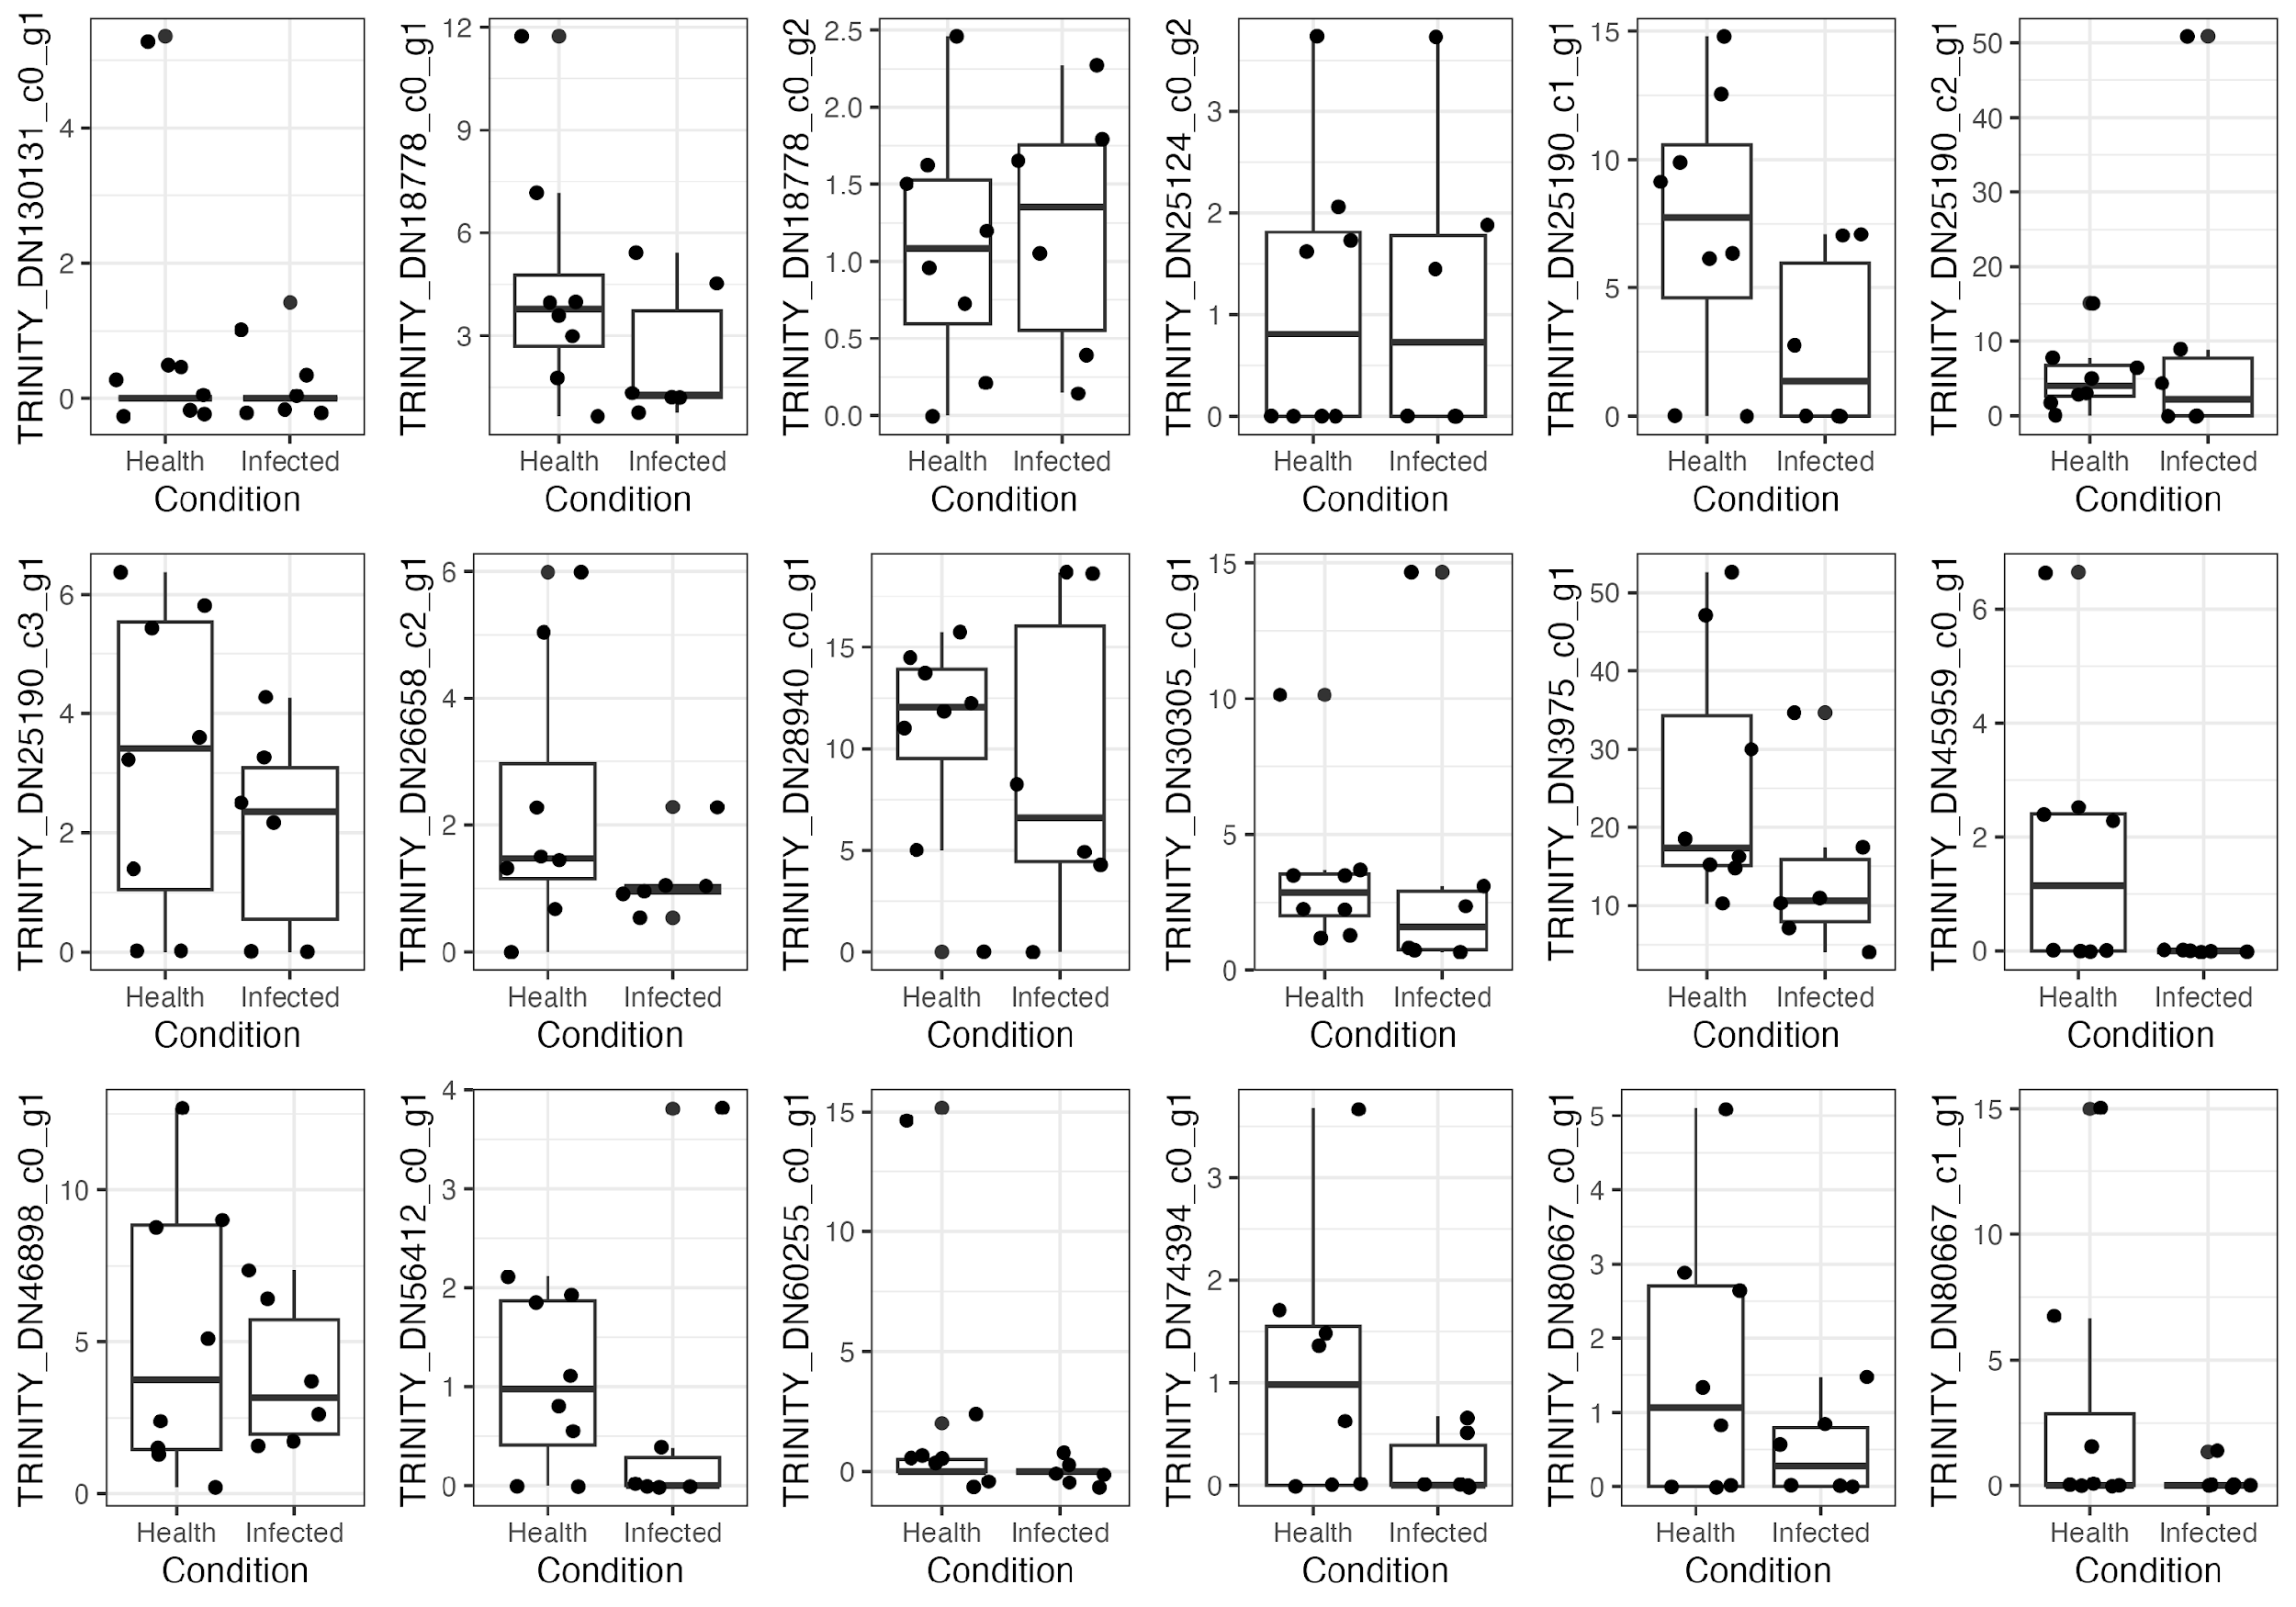

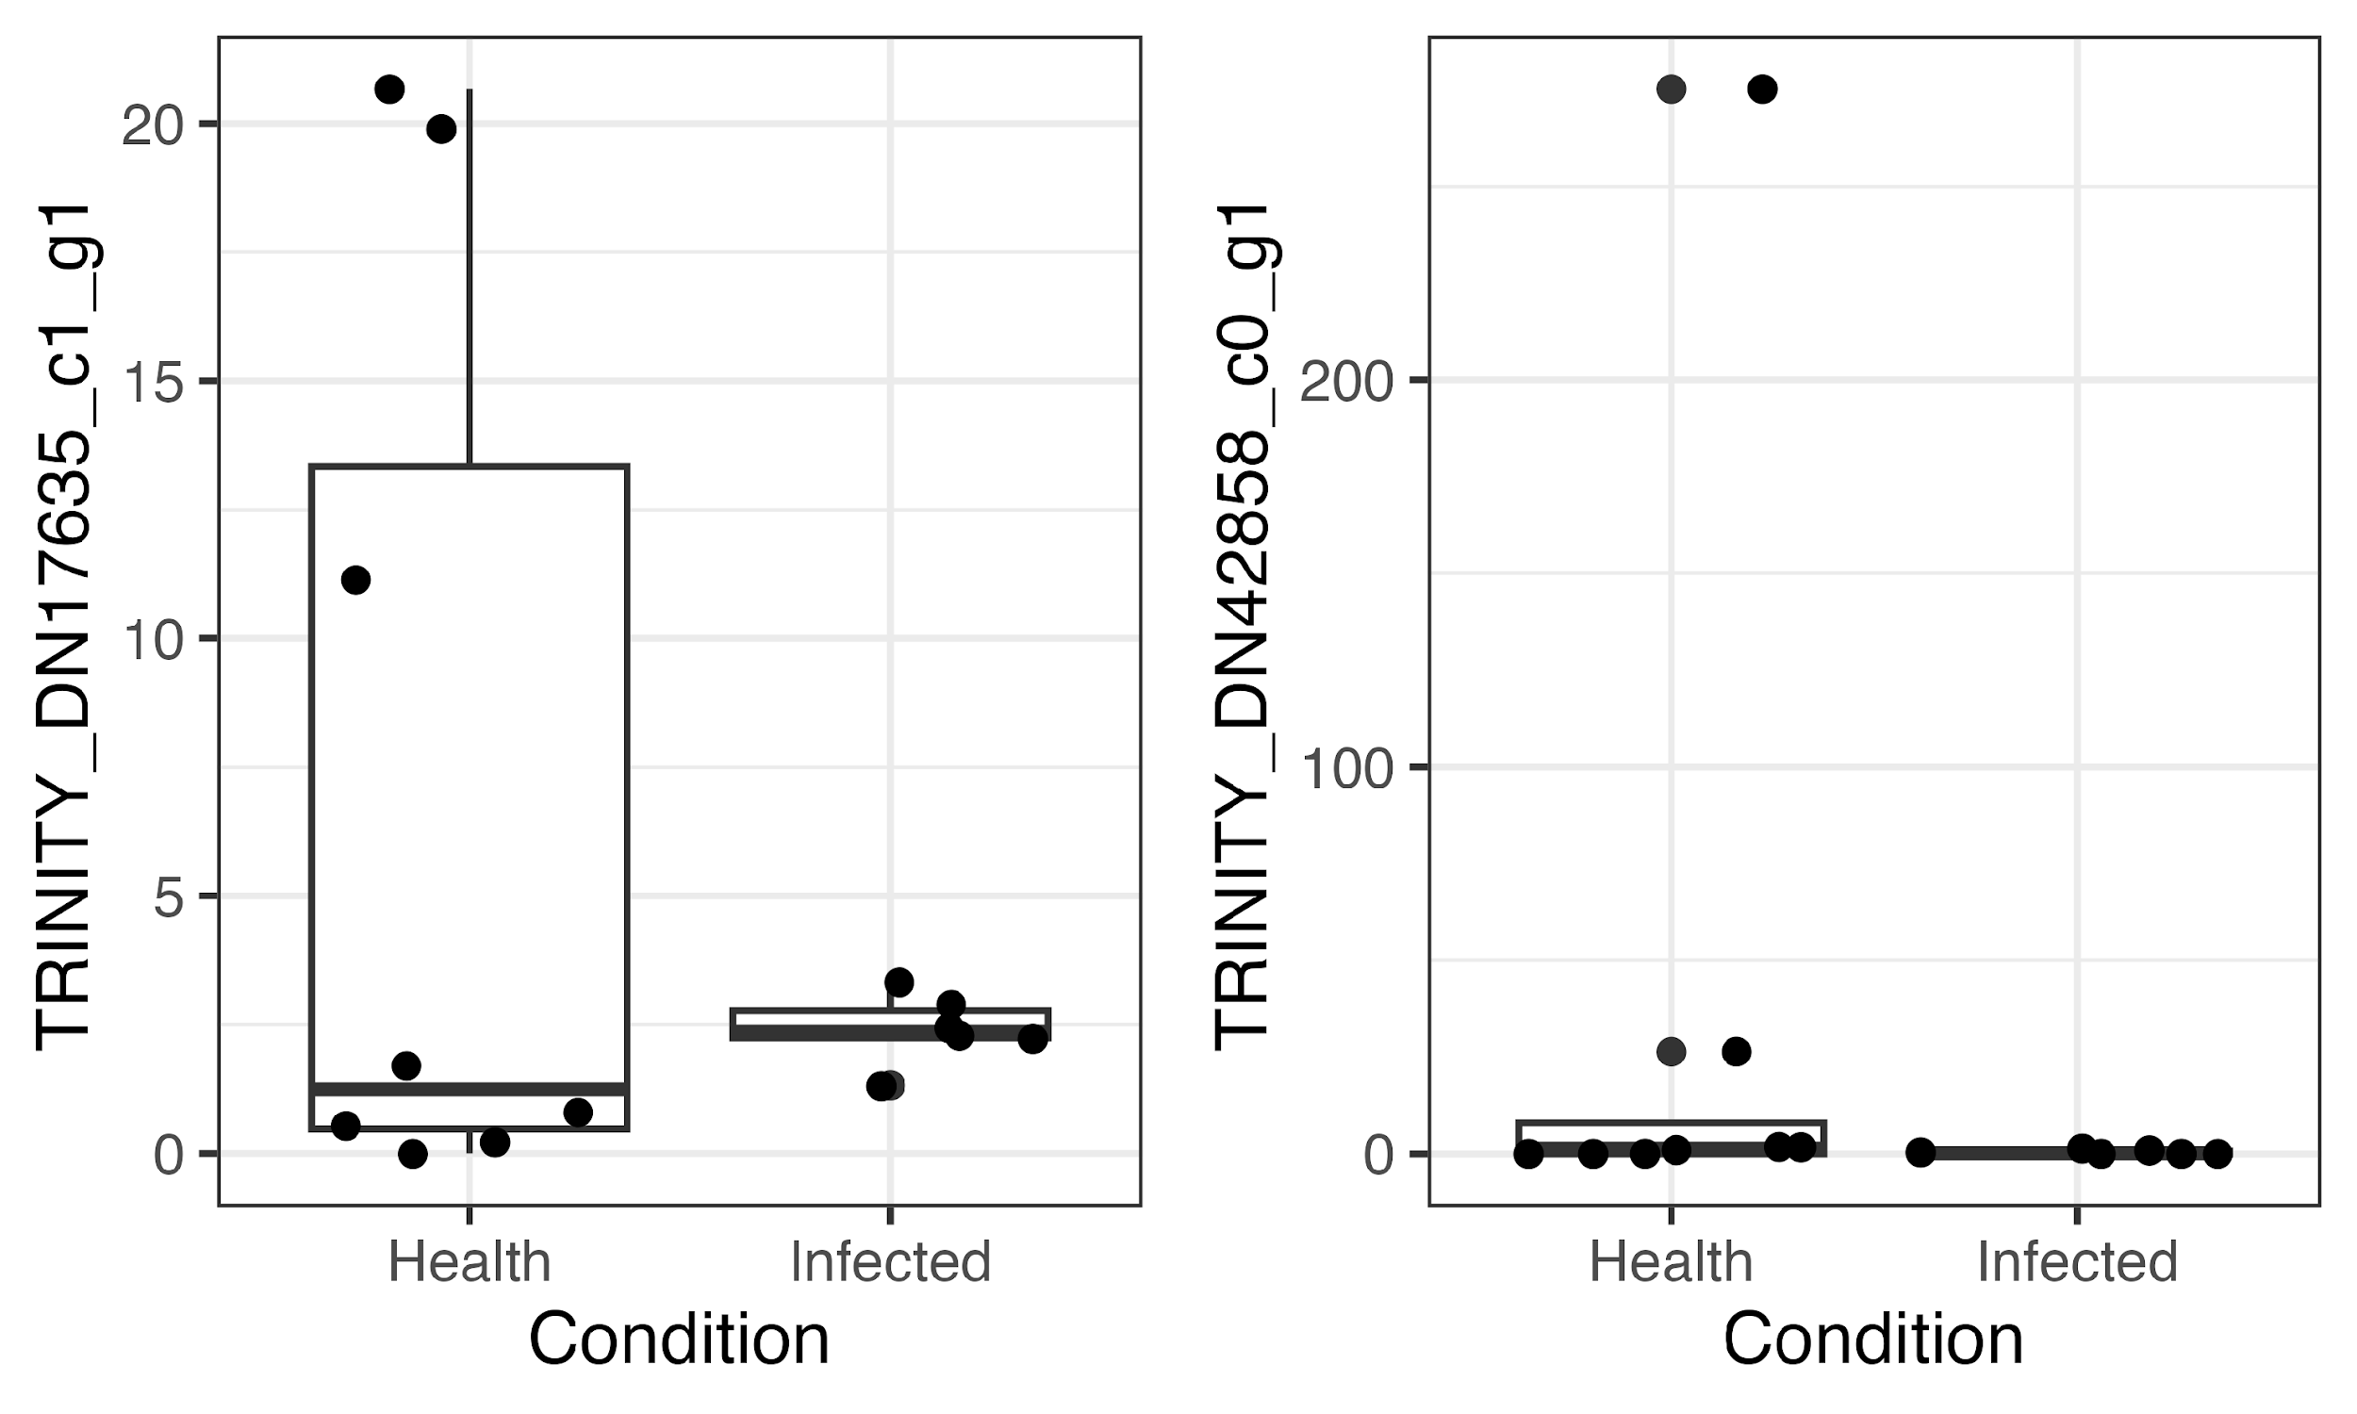

Fig. 2. Expression levels of homologues of Gram-negative bacteria-binding proteins (GNBP) in two mollusc groups.

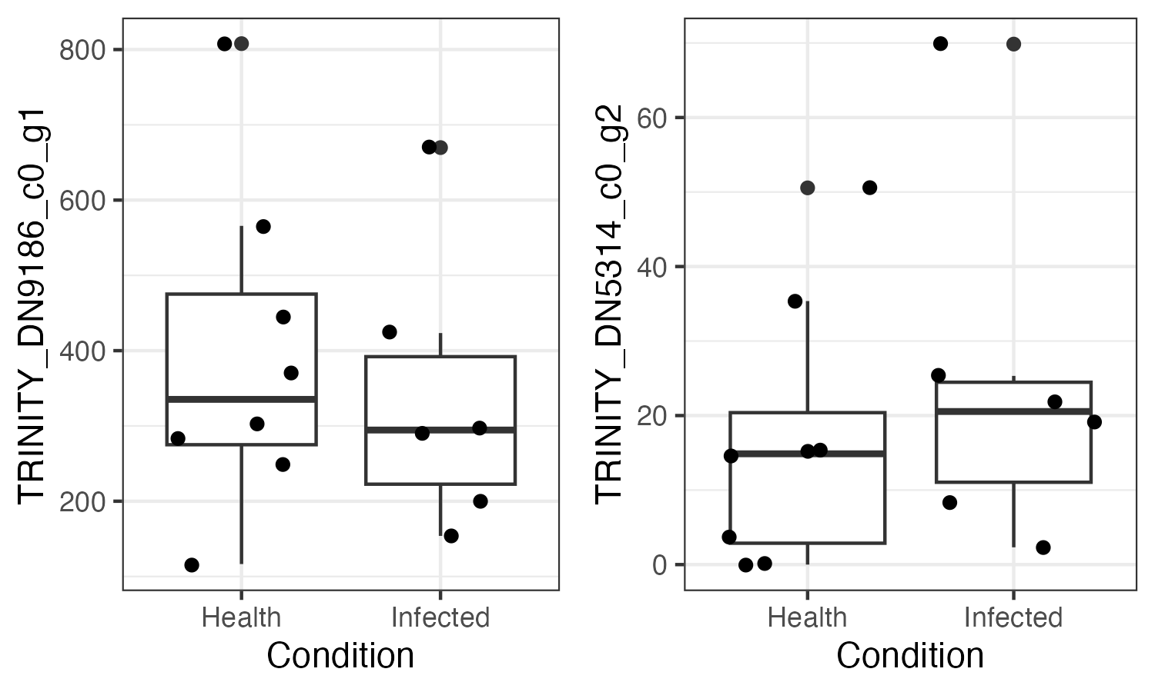

Fig. 3. Expression levels of homologues of Peptidoglycan recognition protein (PGRP) in two mollusc groups.

**Supplement 5.** **Transcriptome assembly statistics.**

Table 1. Transrate assembly quality assessment.

|  |  |
| --- | --- |
| 1. Number of contigs (n_seqs) | 1. 580518 |
| 1. Mean contig length (mean_len) | 1. 825.4974 |
| 1. Number of contigs >1kb (n_over_1k) | 1. 134619 |
| 1. Number of contigs with ORF (n_with_orf) | 1. 112136 |
| 1. N50 | 1. 1353 |
| 1. Reads mapped, % (p_fragments_mapped) | 1. 85.4 |
| 1. Good mappings, % (p_good_mapping) | 1. 74.1 |
| 1. Number of potential bridges (potential_bridges) | 1. 196621 |
| 1. Segmented contigs, % (p_contigs_seqmented) | 1. 10.7 |
| 1. Score | 1. 0.2065 |
| 1. Optimal score | 1. 0.3698 |

**Supplement 6.** **PCA sensitivity analysis.**

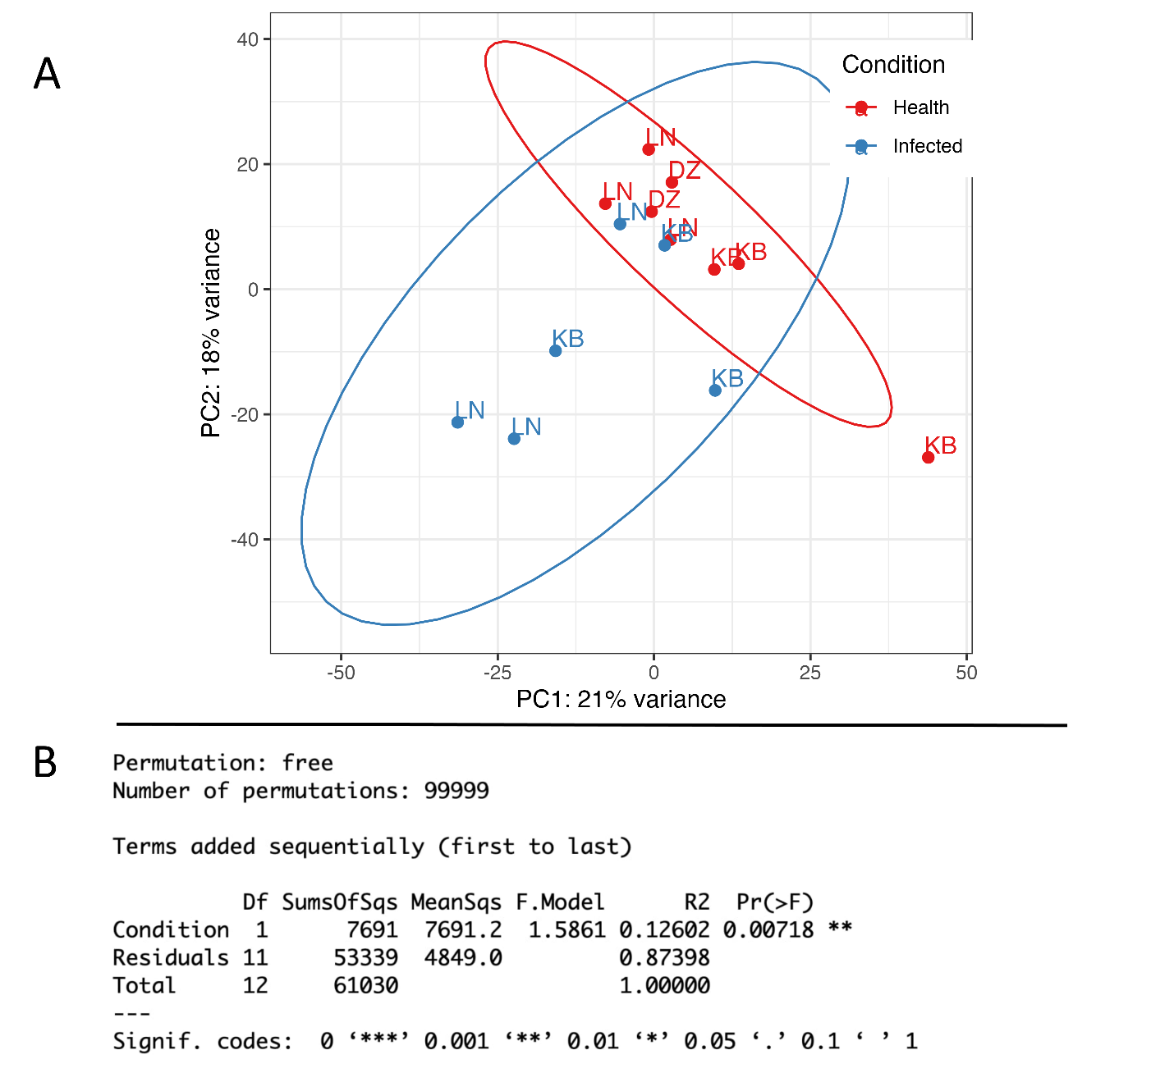

A. PCA plot shows two diverging groups supported with perMANOVA (p-value = 0.0045, 100000 permutations). LN — Levin Navolok, White Sea; KB — Kola Bay, Barents Sea; DZ — Dalniye Zelentsy, Barents Sea.

Ellipses representing 2 standard deviations are plotted on the ordination. One sample from the Healthy group falls outside of two standard deviations.

B. perMANOVA test conducted on the data with the outlier removed. Condition (Healthy, Infected).

The test was performed on the dataset with the outlier excluded. The analysis revealed significant differences between infected and healthy samples, consistent with the results of the analysis of variance on the full dataset, which were presented in the manuscript.

**Supplement 7.** **Sequence identifiers (NCBI) of immune gene homologues found in this research.**

|  |  |  |
| --- | --- | --- |
| TLR | TRINITY_DN130131_c0_g1 | PQ857768 |
| TLR | TRINITY_DN18778_c0_g1 | PQ857769 |
| TLR | TRINITY_DN18778_c0_g2 | PQ857770 |
| TLR | TRINITY_DN25124_c0_g2 | PQ857771 |
| TLR | TRINITY_DN25190_c1_g1 | PQ857772 |
| TLR | TRINITY_DN25190_c2_g1 | PQ857773 |
| TLR | TRINITY_DN25190_c3_g1 | PQ857774 |
| TLR | TRINITY_DN26658_c2_g1 | PQ857775 |
| TLR | TRINITY_DN28940_c0_g1 | PQ857776 |
| TLR | TRINITY_DN30305_c0_g1 | PQ857777 |
| TLR | TRINITY_DN3975_c0_g1 | PQ857778 |
| TLR | TRINITY_DN45959_c0_g1 | PQ857779 |
| TLR | TRINITY_DN46898_c0_g1 | PQ857780 |
| TLR | TRINITY_DN56412_c0_g1 | PQ857781 |
| TLR | TRINITY_DN60255_c0_g1 | PQ857782 |
| TLR | TRINITY_DN74394_c0_g1 | PQ857783 |
| TLR | TRINITY_DN80667_c0_g1 | PQ857784 |
| TLR | TRINITY_DN80667_c1_g1 | PQ857785 |
| PGRP | TRINITY_DN9186_c0_g1 | PQ857786 |
| PGRP | TRINITY_DN5314_c0_g2 | PQ857787 |
| GNBP | TRINITY_DN17635_c1_g1 | PQ857788 |
| GNBP | TRINITY_DN42858_c0_g1 | PQ857789 |
| NO-synthase | TRINITY_DN26654_c0_g1 | PQ857790 |
| DuOX | TRINITY_DN39_c0_g1 | PQ857791 |
| DuOX | TRINITY_DN756_c0_g1 | PQ857792 |
| DuOX | TRINITY_DN10008_c0_g1 | PQ857793 |